# 

# Abstract

Weather forecast systems for pilots are always expensive to maintain and to create. with over 115000 commercial flights a day it is becoming more necessary to provide more efficient weather forecasts to maintain the safety of crew and passengers. the aim of the project is to create a weather forecast application that can deliver accurate information as close to real time as possible to pilots. This being done to aid pilots in creating flight paths and helping reduce potential hazards to airplanes. While some applications have been created for this issue their still remains improvements to be made such as improving delay on weather forecast reporting and user interface. to achieve this goal knowledge of aviation regulations will be required to help aid in how the information is presented. Weather forecasting is a comprehensive science that depends on a lot of aspects and usually done by huge enterprises. To combat this, It will use application programming interfaces to display data from other websites to gather weather information.

Contents

1

Abstract 1

Chapter 1 Introduction 6

1.1 Background 6

1.2 Project aim 7

1.3 Project objectives 8

1.4 Problem description 8

1.5 Project feasibility 8

1.6 Project scope 9

1.7 Project methodology 9

1.8 Project challenges 9

1.9 Project motivation 10

1.10 Project outline 10

1.11 USDG Goals 10

1.12 Summary 10

Chapter 2 : Literature review 11

2.1 Literature Review 11

2.2 Literature review of academic papers 11

2.3 summary 21

Chapter 3 Pre-Design 21

3.1 introduction 21

3.2 Database entity relationship diagram 22

3.3 UML diagram for weather forecast system 23

3.4 Project components 24

3.4.1 Web Browser (client) 24

3.4.2 Web application server 24

3.4.3 Database server (mySQL or Microsoft Access) 24

3.4.4 CheckWXapi 24

3.4.5 Google maps API 24

3.4.6 Windy API 24

3.5 Gantt Chart 25

3.6 Summary 25

CHAPTER 4 IMPLEMENTATION 26

4.1 Design procedure 26

4.2 Working procedure 28

4.3 Algorithm 32

4.4 Site map 32

4.5 API/Webapp relationship diagram 33

4.6 Project requirements 33

4.6.1 Software requirements 33

4.6.2 Hardware requirements 34

4.7 Software design 34

4.7.1 Windows operating system 34

4.7.2 Visual studio code 34

4.7.3 XAMPP 35

4.7.4 CheckWXapi 35

4.7.5 Windy API 35

4.7.6 Google Cloud 36

4.7.7 OpenSky API 36

4.7.8 GitHub 36

4.8 Project Cost 37

4.9 Summary 37

Chapter 5 System implementation and testing 37

5.1 Software implementation 38

5.1.1 Software installations and database 38

5.1.2 Web page 41

5.1.3 METAR page 42

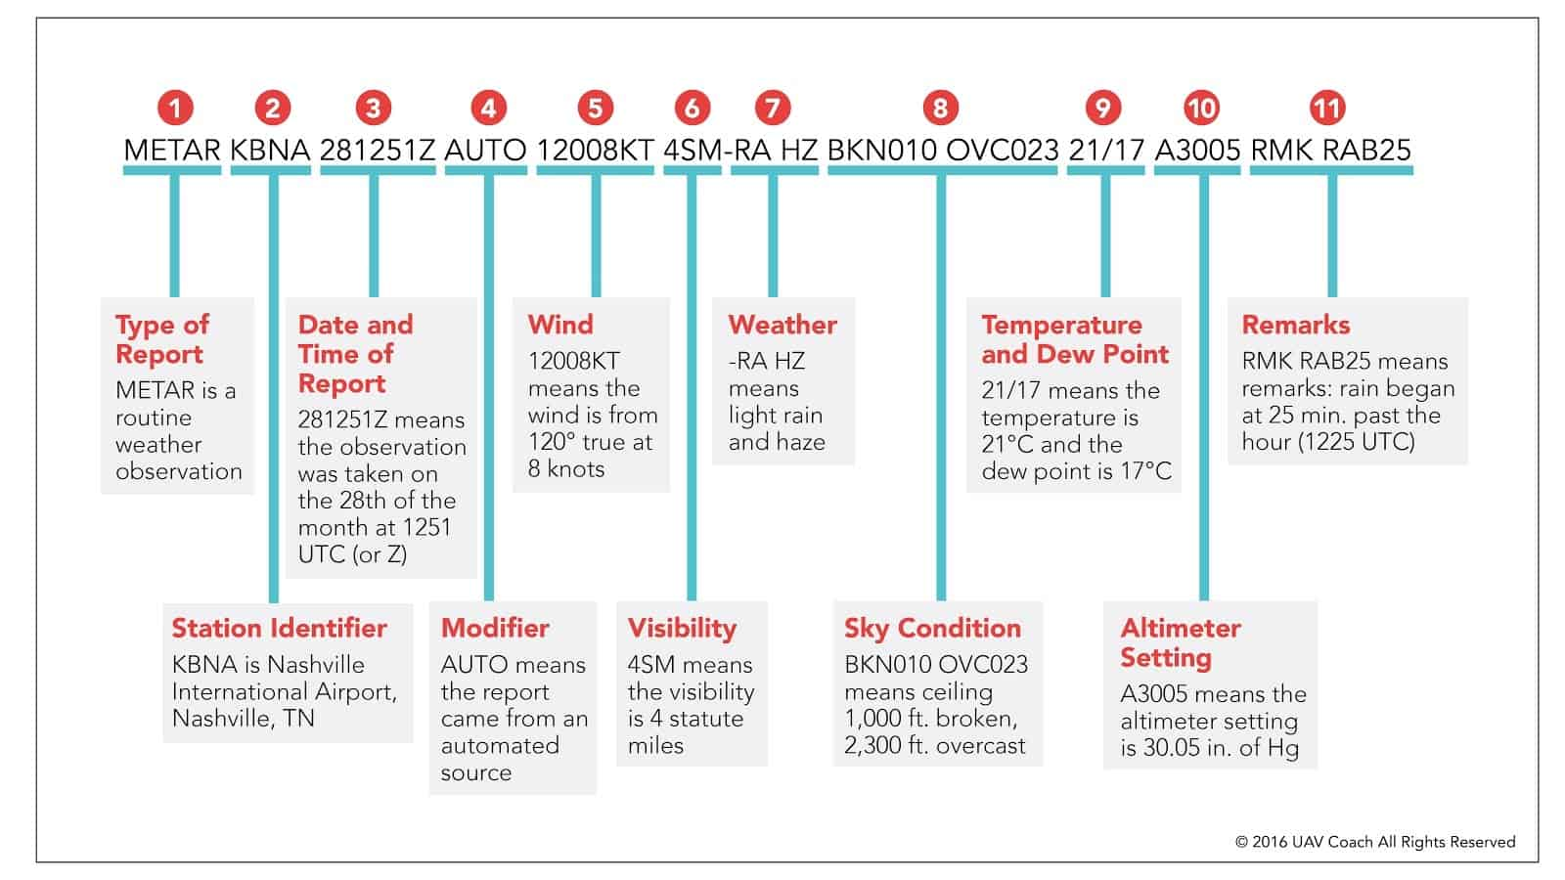 45

5.1.4 Weather map page. 47

5.1.5 Airports page 48

5.1.6 Live Tracker page 49

5.1.7 register page 50

5.1.8 fuel calculation page 51

5.2 System testing 52

Chapter 4 Conclusion 52

Chapter 5 Further work 53

References 54

Approved Project proposal 59

# Chapter 1 Introduction

## Background

There are many of the weather forecasting applications currently used for aiding airplane pilots plot routes for their flight paths. All of these applications suffer from a variety of issues that can and are hindering pilots from effectively monitor these issues. For example, a delay in the application receiving a storm warning that can affect the flight path. While also some systems are not updated correctly according to news around the world for example, an instance where a similar application did not include a no-fly zone warning to the pilots using their application. All around the world there are established flights paths given to all airlines around the world. These paths are extremely important for pilots in their preparation of the flights. The paths given are established with giving pilots leeway in case something happens to the plane such as staying closer to other airports during its flight. Many weathers forecasting application that are aimed at the aviation business are paid applications, these types of projects require huge funding due to its tough project cycle and its reoccurring maintenance costs. While also many of these projects fail because of lack of knowledge in relation to aviation regulations (www.caa.gov.om, n.d.).

Weather forecasting is an extremely important part in aviation, it provides pilots knowledge of future events that can affect their flights. While also placing importance in the safety of people traveling in airlines. While these types of applications are widespread there are many issues that plague them. Due to a myriad amount of aviation regulations that have to be followed for safety measures. For example, many airlines do not fly over the Pacific Ocean because safer and shorter paths exist. Over a 4-year span from 2003 to 2007 there were over 1740 aviation accidents that were affected by weather. (Gultepe et al.,). While these advancements in technology have certain certainly decreased the amount of aviation incidents resulted by weather. through the use of These applications many airlines and pilots use them on a regular basis determine their flight paths and routes, check on any weather factors that might affect the flight, plot a route that keeps them close to airports in case of any accidents or engine failures. All these applications require yearly subscriptions by airlines that cost a hefty sum and or costly to maintain.

A weather forecasting application made to aid pilots in plotting and navigating flightpaths and routes will be created. The purpose of this application is to create an Web based system to allow pilots to check and maintain a high degree of safety. To create escape paths to nearest airports in case of engine failures. The aim is to create a free application for all pilots to be able to use, to help and aid in flight safety procedures. This type of application can help many issues such as decreasing operating costs for airlines. Can give airports a chance to open or close depending on the weather, allows air traffic controllers more information on whether to space out landings and gives them an opportunity to manage the number of aircrafts. This application can provide the aviation business more control and information on health and safety for its employees and customers.

## Project aim

To design and develop a weather forecast application that gathers weather information in real time and displays the information to help pilots in flight path and route plotting to reduce flight accidents and increase safety.

## Project objectives

1. To review and analyze current applications used in weather forecasts in aviation sector.
2. To study relevant aviation regulations relating to how weather can impact flight paths and how to choose which relevant data to display.
3. To study and understand about the tools required to implement the proposed system.
4. To design and develop a weather forecast application that will collect information from other systems and aid in aviation safety and flight path plotting.
5. To complete testing of the system using a wide array of weather instances around the world and to also compare the accuracy of data using other similar applications.

## Problem description

The application used for weather forecasting in aviation are used to increase flight safety and help organize over 115,000 flights a day according to FlightRadar24. With many of these services being paid by airlines and require huge amounts of funding and manpower to create and maintain daily. Due to the many hurdles that weather forecasting presents there are troubles with these systems where the information is not presented accurately to delay of server communication. Due to the huge funding required to take on this type of application, weather forecasts from other system will be shown. This project aims to solve the problems that weather forecasting applications for aviation face by:

* Creating an application which gathers and displays weather information as close to real time as possible.
* Follow strict aviation regulation in Oman and around the world. While presenting weather information to improve flight path safety and reduce aviation hazards.
* Use HTML5 and JavaScript to show weather data and allow pilots to view airports accurately according to worldwide aviation regulation.

## 1.5 Project feasibility

This project requires almost no components that are not already available in the university. According to prior research this project only requires information on programming languages and a personal computer. Furthermore, since the creation of weather forecasting application for route plotting requires meteorological data that cannot be accurately obtained without large funding. The project will use data gathered from multiple systems and display them in the application. It will also require funds to buy subscriptions for other similar systems, to research and determine what should and should not be done. Overall, this project should cost between 20- 50 OMR. Most importantly this project required thorough research into the best Weather API to use and substantial research into the aviation regulations which need to be followed. While also the project will require the use of the internet to gather information for literature review.

## Project scope

The project’s main scope is to create and enhance the methods used in weather forecasting application for aviation purposes. The project should develop an easy-to-understand layout for pilots to use and plot routes. It should also allow the user to view weather information for the next 48 hours. While also providing existing flight paths that are used worldwide and showcase them to the user. Moreover, the system should also show the closest airports to a specific route, and any weather fluctuations during the course of the flight. The application should run on android devices and store user information such as login details.

## Project methodology

For this project to be completed well, it will require a thorough literature review. Where details of previous works will be analyzed to figure out the best possible design choices for the project. it will allow the structure of such applications to be studied and give a multitude of choices for the weather forecasting application for flights paths to evolve into. Through this critical analysis of past papers, it will allow this project to identify the best possible weather API to use for it. The past research will give insight into how to best utilize the coding language such as HTML and JavaScript to measure how each language was used to create a weather forecasting application. The issues that previous projects faced will be learned from and studied as to avoid having to deal with the same issues. The application will mainly use HTML5 and JavaScript and will also choose a weather API to gather information on it. The system will use either noSQL database or Microsoft Access depending on which is better suited for the project. a user profile must be created for each user with login details and previous routes they plotted. While also the system must remember which city the user has favorited for weather forecasts and display them. Since there are more than 115,000 commercial flights a day according to FlightRadar24 the application will be centered around the middle east region so as to contain the scope of the project.

## Project challenges

* Aviation regulation is very comprehensive and requires a lot of knowledge to comprehend, therefore interviewing a pilot is required.
* No prior experience in developing a weather forecast application, but with experience of creating other applications It will only need more time to complete.
* Collection of weather information and delivering as close to real time as possible. Due to weather forecast requiring a lot of moving parts such as satellites. This can be done by comparing other systems and learning from them.
* The best and most used applications for pilots are usually paid subscription services, this will provide some difficulty in analyzing other application. Many tutorials on how to use them are uploaded to the internet.

## Project motivation

The main motivation for this project was hearing from relatives in the aviation business about how these applications for weather forecasting always was missing something. While also hearing of how expensive the subscriptions for these types of systems. With better tools the pilots can foresee and respond well to future weather transformations. As per previous research presents these systems allow for better health and safety procedures for flights and can provide more potential growth for the aviation market. This project provides an opportunity for experience and skills gathered in college to be presented and utilized to create this project. if completed well this can lead to an increase in flight safety, provide customers with safety and security of mind.

## Project outline

The proposed project in this paper will contain three chapters, the fist chapter will be introduction. It will give a brief explanation on what the project is supposed to accomplish, show what hurdles that the project must overcome to reach its goals, the motivation for starting the project, the scope and methodology for the project. the second chapter will include a literature review that overlook and review past papers. It is important for the project review past paper and research to improve the project and find faults and where it can improve. While also learning on which weather API’s to use and how to best utilize the coding languages to create the best possible project. the third and final chapter is pre design and analysis, it will include a diagram of the proposed system, a block chain diagram for the system. Will also include a flow chart and a Gantt chart to display the time required to complete such activities. In the end of the project a conclusion will be made to review the outcome, while also giving future work to be completed to clarify the future advancements.

## 1.11 USDG Goals

The project meets the 8th goal of the USDG Promote sustained, inclusive and sustainable economic growth, full and productive employment, and decent work for all. Promote decent work and safe working environments for all: men, women, youth, people with disabilities and migrant workers.

While also it meets the 11th goal Make cities and human settlements inclusive, safe, resilient and sustainable. As it prepares communities to properly manage their resources and tackle climate change.

## Summary

This chapter is just an outline for the project idea, the motivation and aim behind it. It also provides a background of the project problem, the methodology of the project and how it will be created. The scope of the project and key challenges that the project will face.

# Chapter 2 : Literature review

## 2.1 Literature Review

A literature review is a review and analysis of previous work related to the subject. It researches and identifies works by previous authors that created projects and literature relating to weather forecasting applications. This will include the findings of the other papers and conclusions, find their strengths and weaknesses. It will focus on the methodology of the papers and system design, how they achieved their results. This chapter’s main priority is finding where these authors succeeded and failed and compare between them. While also learning from them to include in the proposed project, by reviewing previous authors work’s testing methods and use of coding languages and databases can help improve the project. comparisons between some of the different authors work in applications for weather forecasting application for aviation.

## 2.2 Literature review of academic papers

In this paper by Beeharry, fowder and sunglee (2019) it researches the use of cloud-based databases to give real time predictions of weather forecasts in an application. The authors mention the importance of delivering real time information for weather forecasts and how it can affect the economy. While also the paper includes the worlds need for transferring big amounts of data quickly, how some technologies can benefit from the use of cloud-based techniques. The authors go through a multitude of research into how the project can be completed and they compare other articles and their use of databases to their own plans. The authors create a weather forecasting application that gives predictions of weather up to 20, 40 and 60 minutes ahead in time. It is mentioned in one of the references of the article that large amounts of data storage is required to make weather predictions and forecasts (Sahl et al., 2018). Furthermore, the article explains well in the introduction the need for cloud computing in weather forecasting. In the introduction the authors present evidence from other articles on how much weathercasting can benefit from the use of cloud databases. The authors go through multiple cloud computing services such as Azure cloud platform and google cloud. While also providing research from other authors that have produced application using these providers. Giving details on why they used such platforms and also researching the costs of using each platform that can be seen through their references.

The authors Beeharry, fowder and sunglee decided that the best course of action was to make their cloud-based real time weather forecasting application using International Business Machines (IBM) could platform. While also as this a NoSQL service it allows for handling of big data as huge data handling is required for weather forecasting. This project uses a separate weather collection sensor and then feeds it into the database, it measures temperature, humidity, wind speed and wind direction and many more information is being gathered (Beeharry, Fowdur and Sunglee, 2019). The data gathered is then sent over to the IBM database platform after transferring it into a JSON format. The authors use IBM cloud platform services such as the cloud foundry apps to host the webpage and continuous delivery service for real time storage and retrieval of big data.

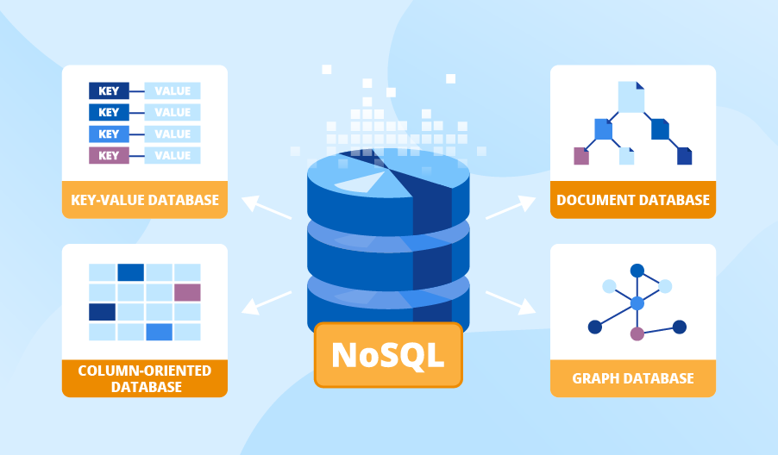

Figure 2-1 NoSQL database types

In the figure 2-1, it explains the types of databases that are included in NoSQL databases. The authors of the project used document type database and that the parameters that the big data passes through are stored in document type databases. This type of database is made to store and query data as JavaScript Object Notation (JSON). This makes it easier for developers to store and query data by using the same document format (Strauch and Kriha, n.d.). the authors of this paper used IBM which is a NoSQL databases, this allowed them to have flexible indexing for their weather forecast application.

Furthermore, the paper mentions the use of IBM develops insights to deploy JAVA based prediction algorithms to give the 20-, 40- and 60-minute predictions. This is then integrated with the Eclipse Orion web utility for coding purposes, this is a part of the IBM platform. The authors use eclipse IDE to create Class and Method techniques and this similar to the way it is made on other programming languages. The authors then go on and show a sample of the prediction algorithm used in their project and explain that it operates on JAVA 1.8 compiler.

Furthermore, the paper then explain that they had some issues with IBM DevOPs in which they had to rewrite some of the code for the algorithm. The authors do well to mention the issue that they faced but should explain in more depth in regards to this. The solution they presented was to restrict the amount of data entered and only keep a two-hour window of data to only complete the algorithm.

The authors then mention the results and conclusions of the project, that a web interface and android application was both completed. Also providing pictures of how the completed project looks.

In conclusion, this paper does extensive research into the topic before implementation and provided many citations on different approaches to cloud-based computing for real time data transfer. The authors should be commended on their research but the paper is lacking in some sense. While they did have issues in programming the application it is only mentioned in one line and does not delve deeper in the issue. The motivation for their paper is also quite unclear and only that they chose weather forecasting as a topic due to its need for large amounts of data. The authors work was built upon another work by the same authors, and in that paper it delves much deeper into the need of weather forecasting and the importance of delivering data as close to real time as possible.

In this paper by Wahdiniwaty, Setiawan, Auliardi and Wahab (2019) it discusses the creation of an android-based application for travel recommendations. This paper discusses the use of open-source API’s to create a travel recommendation application by incorporating the use of google maps API and Open WeatherMap API. Their purpose is to create an application that can take factors like weather and distance to help recommend good travel locations for their users. From the introduction the authors explain their motivations to create this application. While also explaining the issue of tourists not knowing the best locations to go to. They provide evidence to this problem by showing data from a questionnaire where 64.3% of perspective tourists had issues planning tours (Wahdiniwaty et al., 2019). From thereon, the authors review only two previous works related to the same subject in the introduction. While their reviews are comprehensive in how and what was used by previous authors to create their project it certainly is lacking in quantity and does not provide enough perspective. This paper explains clearly its desire for creating this application and has done well in providing statistical data to support its arguments.

The authors explain the uses for API’s and which of them they would require to complete their task of which are google maps API, Open WeatherMap API and Facebook API. These API all relate and aid in the formation of their work. The authors clearly explain why each one has its uses such as Google maps API allowing them to measure the distance of the user and the tourist attraction. The Open WeatherMap API gives them information about weather conditions in each of the locations for tourist attractions. The authors then state that an application such as theirs can help identify public transportation routes and nearby hotels for tourists.

In the literature review section of the paper, it goes through six sections of which starts with tourism. To begin this section the authors, write on the importance of tourism to a country’s economy. Then going on to recommendations which in this article refers to a decision support system (Wahdiniwaty et al., 2019). Although the first two sections are comprehensive it comes off as somewhat unimportant in the literature review and is supported by little references and citations. The third section google maps API explains how if used effectively the project can succeed in placing markers for the user and giving directions to the chosen tourist locations. An API is an application programming interface it allows applications to integrate features from other applications onto itself. The authors continue by providing information on open WeatherMap API as it provides the latest weather forecast data and receives them from airport weather stations around the world. From thereon, Facebook API is mentioned and is used to allow users to seamlessly login through Facebook services. Although this method allows for easier user entry it also places private information at risk. Since Facebook has been hacked multiple times and lost sensitive user information (McCown and Nelson, 2009).

The research methodology of the paper provides a simple and concise explanation on how they are going to approach the project. but it is missing some factors, since they are going to make an android application some sort of programming language should be mentioned. While also a giving a design approach for the project. e

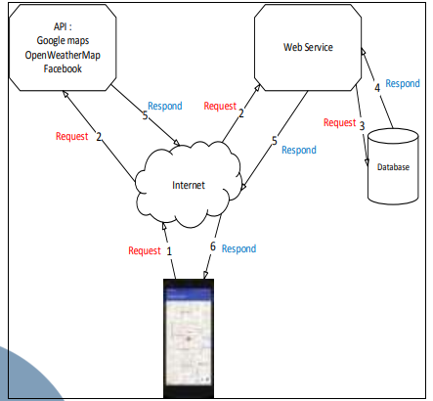In the results and discussion section, it provides some system analysis for the front end of the web application as seen in the figure below.

Figure 2-2 Mobile system architecture (Wahdiniwaty et al., 2019)

To explain figure 2-2, the user sends commands via an internet connection and it is passed to APIs such as Open WeatherMap and Google maps. From thereon the webservice sends the query to the database and so on. The authors explained the process really well and provided an easy to understand figure for the reader. After the explanation on how the system worked the authors delved deeper into the APIs they used. How google maps was used in tandem with GPS to track the user’s location and provide with an appropriate distance measurement from all the tourist attractions. While also explaining how they got the google map API and the steps it took. Google maps has had a huge impact on tourism and has allowed travelers to clearly get from their desired destinations. The authors explain clearly the steps taken to get each of open WeatherMap API and Facebook API.

In conclusion, this paper from Wahdiniwaty, Setiawan, Auliardi and Wahab (2019) has a weak start by reviewing only two previous similar works and presenting them in the introduction. But has made up for it through clear explanation of each of the components needed to complete this project. in some instances, the authors do no mention what programming language will be used. Although this project is comprehensive it misses out on some simple things that could improve the project.

In comparison with the paper by Beeharry, fowder and sunglee (2019) focuses more on the topic of weather forecasting application using cloud-based systems to get real time information. It provides and showcases better implementation and has done more research into previous works. While the paper by Wahdiniwaty, Setiawan, Auliardi and Wahab (2019), is lacking in the subtext of previous work researched. This paper misses out on simple things that could make it better. The difference between the two systems is that one uses cloud bases techniques to send and receive real time data from a sensor that they have built. While the other system is based on the creation of tourism application that uses APIs such as google maps and open WeatherMap to facilitate important information such as distance and weather forecast. Although the first paper took a more intensive route, their work to get real time transfer of big data did succeed. Although the weather information gathered is restricted to a single location. While on the other hand the tourism application gathered such important information such as weather forecasts of a large are through the use of APIs. The first paper is lacking in regards to key challenges faces and mentions that one issue for JAVA compiler 1.8 but does not go in depth into it. Another difference between the two papers is that one has a short results and discussions section, and it does not do well to expand on their results. But on the other hand the authors Wahdiniwaty, Setiawan, Auliardi and Wahab (2019 ) do a great job in discussing their results and showing every step from their research methodology and expanding on it in the results section. While also this paper for tourism application mentions their desire to create longer durations for weather forecasting and how it can help their application in future works. While the cloud based weather forecasting system does not have mention of any future work.

The conference paper “Weather Forecasting Application Using Web-Based Model-View-Whatever Framework” focuses on the creation of a weather forecasting application. The authors use model view whatever (MV*) framework to provide a varied approach to the creation of the application. They focus of the use of JavaScript AngularJS framework, mainly the data binding and dependencies aspect. Due to the project being a single page application it shows how important the AngularJS framework is in reducing repeated errors through the use of custom directives. The authors achieve their aim by using the model view whatever framework, which allowed them to use Model View Controller (MVC) and Model-View-ViewModel (MVVM) or any other approach in a case-by-case basis. The paper shows how they used JavaScript and HTML to achieve their objective.

The use of Model view whatever (MV*) framework is used to allow the authors to have a varied approach to the single page application. Where they could choose any approach from Model view controller (MVC) and model view view model (MVVM) or other approaches (Bucanek, 2009, pp.353–354). It is used because it provides flexibility for the authors and is regularly used by AngularJS developers. Many research has been done in the case of MVC architecture and its uses. In the case of this project, it seems that using model view whatever allows a small team of developers to create the project according to their needs at specific junctures (Hernandez, 2021). The single page application chosen by the authors means that all resources are fully loaded in the initial request. The authors choice of using a single page application for the weather forecasting application allows more flexibility and provides a unique way with dealing with data (Jadhav, 2015). When projects use JavaScript to create the front end of an application it tends to be very complex and becomes difficult to understand for the developer. This causes an issue when it comes to maintenance as this weather forecast application also requires it in the future. The authors solve this by using AngularJS for the front end as it divides it into three parts. The model, the view and the controller. This allows their code to be simple and easy to maintain as in their future work requires regular updates. But due to the small nature of the project it might not require the use of AngularJS framework and can probably do just as well using JavaScript for the front end of the web application. Both of these methods are considered valid by the scientific community.

Something that might be seen as a weakness for the project is that the data of the weather forecasting is coming from a different source outside the application, from an API to be precise. The authors mention that it might cause a security problem due to the use of an API but have already planned a way to mitigate such things happening. In the references of this article, it mentions research on the development of data systems for weather forecasting. The authors do not mention from where they are acquiring the weather forecast information. This causes an issue of validation where the user in not sure of the accuracy of the information (Osorio et al., 2017). This article which is citied by the authors provides a good basis into the collection of weather forecast data. But weather forecast information varies due to the location of the institute that is gathering the metrological data. A different journal article shows that over the past two years they have noticed a decrease in accuracy in weather forecasts (Chen, 2020).

Since a security issue might occur in the web application due to an application programming interface (API). When using it the browser thinks that it is being hacked. the authors avoided this by using a call back function in AngularJS and it is a feature in JavaScript in general. It is a way for a function to call on another function once the task at hand is finished (Williamson, 2015). This is used to prevent the browser from stopping the API and controller from completing the task.

The authors provide and show a deep understanding of AngularJS dependencies and data binding. As using this structural framework allows them to use HTML as a template language and improve its syntax to allow them to write less code. The websites and books that the authors use provide a good sample size of uses for AngularJS dependencies and data binding. While also delving deep in how they use it for their project and why it is useful for it (Green and Seshadri, 2013). They also provide examples that all ow readers that are not familiar with the topic to better understand why and how they are using it. The web application allows the user to select any city across the world to see its weather forecast information. This is done use the controller aspect of Model View Whatever (MV*), where the user inputs the desired city and the controller gets the information required and displays it (W3schools.com, 2012). The authors also use custom directives to stop repetition of elements from occurring. This also helps the code to become easier to use by the developers.

Furthermore, the conference paper references an article related to public transportation and how weather affects (Hussain et al., 2016). The article mentions the importance of weather updates and how it can affect the timing of public transportation which impacts thousands of people daily. This shows the authors understanding of the topic and their need to create such an application. But on the other hand, the results show only the daytime temperature and do no display whether rain or cloudiness is expected. This does not help the issues that the referenced article mentions in regard to public transportation. The authors mentioned that this is a possible future work that can be completed.

In the case of this project the user is allowed to input any city and view the corresponding data. But from a reference article in the conference paper, it shows that in cities the weather is fragmented depending on the size and the location of user (Kolokolov et al., 2017). For example, in the future if the works planned are completed such as providing weather condition of a specific place. The application will only show the weather for the entire city, but if you were in London and it displays that it is raining but it might not be in your area as it is a huge city. The application might benefit from adding more detail to the location of the user to provide more accurate data.

In conclusion, the authors show deep understanding in prior work reviewed and are comprehensive in their work. They provide a clear and concise structure and explain the system required and the methodology behind it. While they state that through their use of an API it could lead to a potential security problem it is backed with reasonable justification.

In the paper “REPORTS THE CURRENT WEATHER CONDITIONS ON CELL PHONES USING WEB SERVICES” by Zhao and Fan (2010), the authors present their way of making a mobile application to report weather conditions to users. The focus on this paper is in creating a two-tier application for the paper which is web application server and client. This means that the website will interact with the user as he inputs commands and gives them an appropriate response. In the introduction the authors explain which components and software is required to create the project such as SOAP which is a messaging protocol that allows for information exchange in web services. Then the authors explain that the webservice application should show a chosen country’s and city’s weather information. They also use an emulator of a cellphone to test the project throughout the process of development. While also including that if information is entered incorrectly an error popup will display to the user. But the introduction is lacking as it does not clearly state the author’s motivation for the project.

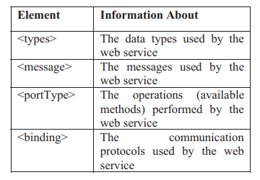The authors then provide a clear and comprehensive review of prior and related work. From the beginning the authors give good explanations of XML web services and how it is the basis for web client communications (Zhao and Fan, 2010). Furthermore, it is mentioned how XML messages will interact with the SOAP protocol. Simple Object Access Protocol (SOAP) is an XML based protocol, it is a frame work for describing the content of messages and the process of displaying them (Box, Ehnebuske and Kakivaya, 2000). The authors do extremely well in the explanations of the process required by XML protocols and continue to elaborate on why it is so important to their project.

Table 2-1 the four elements of WSDL

“WSDL is an XML grammar for specifying a public interface for a web service, the public interface can include information on all publicly available functions, data type information for all XML messages” (Cerami, 2002). The authors explain the table above about the 4 elements of WSDL that will be used in the project. it is clear and concise about the elements used such as binding and port type. While also giving the reader information on how each element affects web services. The paper also states that using SOAP protocol can allow for larger transfers of data to the website. While also SOAP can be used in tandem with different applications to communicate and send data to them (Cerami, 2002). Creating this project as a web service allows the authors to use different applications and gather information from a multitude of services and can combine from other sources. This allows for the web application to gather information such as weather data and send it to the user’s device quickly.

Furthermore, the authors decide on which type programming languages to use such as Java and CLDC to deliver Java core libraries to the web service. The section on implementation showcases their design for a two-tier structure for the weather report system. After the weather information is stored as WSDL file with XML formatting, the algorithm that they have created showcases this information as the client chooses the location. The authors make this clear by presenting the four steps that the website will take to display the weather information to the user of which are, discovery service and WSDL, Semantic and Interact. The semantic part is where the database server will communicate to the client and agree on use of the weather service. From there the client will interact with the database and access its information. The authors provide clear explanations of each of the components needed to create the project such as Stub generation and the importance of a good user interface. In the results and discussion, a problem was mentioned in the coding part, where the information needed to be classified as a thread or it will deadlock and not complete the algorithm. In future versions the authors look to make the application more user friendly and provide different ways to present the weather situation to the client.

In the paper “System design to use weather forecast & current condition information on travel route with KNN and graphical data on Android application” by R. V. Hari Ginardi and Abdul Munif (2017) , the authors create an application that takes in weather information and relates to determine travel routes. The paper states in the introduction that their motivation for the project was that in case of travel weather conditions can sometimes derail the routes that they planned to take. The paper clearly states its motivations in the introduction and follow that up with information on a local authority that measures weather conditions. While also mentioning the importance of good user interface, and it supplemented by stating that they will be using Gestalt’s principles to user interface design. Gestalt’s principles are principles of human perception, how humans see and interact with different patterns. These principles are used in Mobila application development and can lead to better user experience (Ripalda, Guevara and Garrido, 2020).

In the system design section of the paper, the authors recognize the need to use an API to gather the city’s map data. They do this by using Mapbox API and connecting it to the data service Clearroute API and ultimately to the local weather station database which is shown in the figure below.

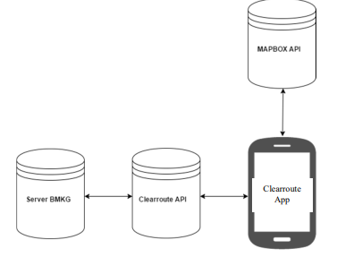

Figure 2‑4 System architecture (Ginardi et al., 2017)

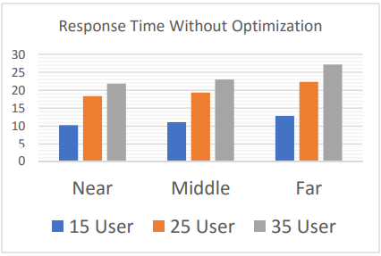The paper mentions that there are two separate data sets required for the application. One which is current weather data, this to display the current weather situation and forecast of weather conditions. From these two data sets the application can display the most optimal route for travel by measuring the distance and weather conditions. The authors also provide a series of tests for the application of which are, time response test and travel route test this to give clear results on how fast and accurate the data provided is. This is a clear strong point for the paper and the authors do well to indicate the need for each test. By gathering 35 user the authors figured out that the slowest time for server response is 19 seconds because this is from the farthest destination that can be inputted, While 6 seconds for the shortest distance (Ginardi et al., 2017). The authors best work in this paper is included in the results and discussion section. It indicates the need for more optimization to increase the speed of the server response time. The authors provide data before and after optimization it shows clear improvement. When 15 users are using the application database simultaneously the time was 10 seconds for the nearest destination before optimization and 6 after. While a decrease of 9 seconds compared for the farthest destinations.

Figure 2-5 response time without optimization (Ginardi et al., 2017)

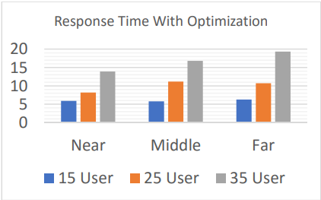

Figure 2-6 response time with optimization (Ginardi et al., 2017)

## 2.3 summary

This chapter discusses related work by other authors, and it includes papers that are of similar scope to the proposed project. It gathers and reviews their design methodologies and discusses the results obtained. While investigating on which components and software techniques used to complete their projects. For example, how for a single location only a sensor is needed and with a large area there is a need to use APIs for weather forecasts. It also compares between different papers methodologies and techniques, with some having faster response times due to cloud-based databases. This aids the proposed project by identifying success and failures of related works and improving it. It also presents a trend in current projects in the same vein and provides better understanding of the software needed to accomplish this.

# Chapter 3 Pre-Design

## 3.1 introduction

This chapter includes details about the initial system design and provides data analysis. It will use diagrams such as database entity relationship diagram to explain the differing segments for the weather forecasting application for flight paths and route plotting. It will give details to explain the working principles of each diagram and chart. It will also present a time frame for the project by producing a Gantt chart. But since choosing a design direction of an application is a difficult task it is liable to change. Since the proposed system still in the early stages it might need to be altered to suit the circumstance. Many aspects will be under scrutiny later on but this a rudimentary stage in developing the application.

## 3.2 Database entity relationship diagram

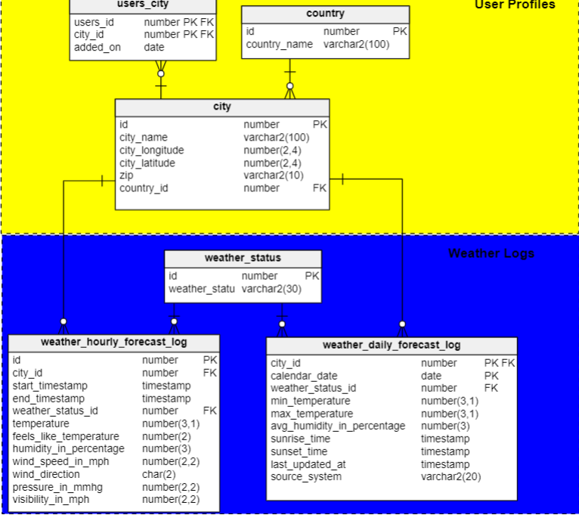

Figure 3-1 Data model for Database (self,2022)

Since the application aims to pilots with as many details regarding to weather forecasts. The database should store the user ID and City of which their flying out from. While also including details about each city using longitude and latitude. The user should be able to select certain routes for flight paths and the database should store information about each city.

In regards to the weather logs it should link into the user selection of city and should provide comprehensive information. Weather conditions will be labelled such as cloudy, foggy, sunny and more in the weather status section. While also recording information regarding wind speed and direction, temperature, visibility in the hourly forecast. While in the daily log should record the date, minimum temperature and maximum during the course of the entire day.

## 3.3 UML diagram for weather forecast system

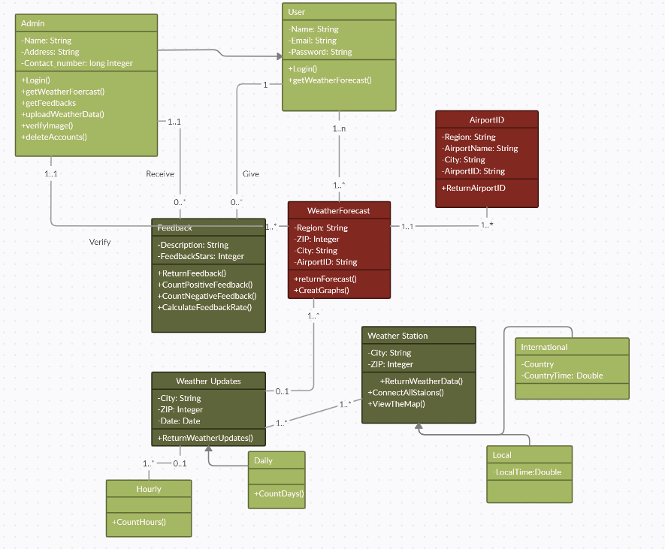

Figure 3-2 UML diagram for weather forecast system (self,2022) using creatly.com

This provides an overview of how the system will interact with each other in the application. There are two types of users, admin and user. Information for admin is stored such Contact, Name and Address while user stores name, email and password. The user can give feedback and the admin can receive the feedback. Both types of client can view weather forecast data which includes weather updates and AirportID. WeatherForecast includes region, ZIP, City and AirportID, which is linked with weather forecast data. Weather updates is split into two factors Hourly and Daily, this data is gathered from the Weather Station section. While time is split into two blocks, Local and International time.

## 3.4 Project components

### 3.4.1 Web Browser (client)

The client handles the presentation of the weather forecasting application for flight paths. It is how the user can interact with the application, the user can input a request and the client sends the request for the system to handle. In this project the client will be a web browser and android, this will allow the user to interact with the services of the proposed system.

### 3.4.2 Web application server

A web application server can accept and fulfil the user’s requests. It allows the client to generate a customized response to the user. It is an extremely important tool as it allows the use of APIs in projects and allows multiple different application to be linked.

### 3.4.3 Database server (mySQL or Microsoft Access)

A database server is where the application is going to store all the user information and weather data. Items such as user passwords and city names will be recorded in the database. It is a requirement to create any web application, as it can store information needed to complete queries. For the proposed project multiple databases are being decided on and will be chosen by the time of development.

### 3.4.4 CheckWXapi

This is the API that will get the Metar and TAF data from any airport around the world. This provides the user with the most accurate weather forecast data from any airport using the ICAO code (International Civil Aviation Organisation).

### 3.4.5 Google maps API

This API will allow the website to use google maps in the project. While also it will allow to add other features onto the map, such as airports and a live tracker.

### 3.4.6 Windy API

A weather map that can show forecasts over a map overlay with many different functions. Such as checking cloud height, air pressure and many others.

## 3.5 Gantt Chart

|  |  |  |  |  |  |  |  |  |  |  |  |  |  |  |
| --- | --- | --- | --- | --- | --- | --- | --- | --- | --- | --- | --- | --- | --- | --- |
| **PROJECT PLANNING GANTT CHART - (RM PHASE)** | | | | | | | | | | | | | | |
| **KEY ACTIVITIES (TASKS)** | **DURATION 1 DIV = 1 WEEK** | | | | | | | | | | | | | |
| **1** | **2** | **3** | **4** | **5** | **6** | **7** | **8** | **9** | **10** | **11** | **12** | **13** | **14** |
| 1. Choose project title confirm with supervisor. |  |  |  |  |  |  |  |  |  |  |  |  |  |  |
| 2. complete project proposal |  |  |  |  |  |  |  |  |  |  |  |  |  |  |
| 3. CW1 |  |  |  |  |  |  |  |  |  |  |  |  |  |  |
| 4. CW2 |  |  |  |  |  |  |  |  |  |  |  |  |  |  |
| 5. Recheck coursework 2 and submission |  |  |  |  |  |  |  |  |  |  |  |  |  |  |
| 6. |  |  |  |  |  |  |  |  |  |  |  |  |  |  |

## 3.6 Summary

This is an important stage in the development of the proposed project as it provides some clear direction for the project to head in. It also discusses some diagrams that are vital to the project. Furthermore, this chapter gives a general outline of what is planned to use for the implementation and testing stage. API such as google maps and CheckWXapi will be vital in obtaining and displaying weather forecast information. This still subject to change during the project lifecycle but should give a reasonable outline.

# CHAPTER 4 IMPLEMENTATION

This chapter will include the steps taken to implement the weather forecast application for aviation. It will give the proper procedures taken to create the system, it will utilize the aspects from the prior chapter and provide more depth. It will follow the design steps taken to implement all aspects of the project. While also expanding on the required project components and explain why they have been used. Furthermore, this chapter will also explain why the required programming languages such as HTML, JavaScript and PHP, and the database application used are needed to connect the APIs. This an important step to showcase the system design. This can show how the components used allows the application to access weather information in real time. To accomplish the creation of the system it requires some knowledge on METAR (Meteorological Terminal Air Report) and TAF (Terminal aerodrome forecast). This is required because of the calculations needed to be able to decode this information since it is provided in symbols. It will also provide a cost report of the components needed. The project was built as a web application and used HTML and CSS to display the information while JavaScript and JSON were used to handle all calculations and calls to the various APIs used. Of the different web pages in the project the main objectives of the project can be found the METAR and Weather map pages.

## 4.1 Design procedure

Prior to the implementation of the project, a number of different objectives needed to achieved and corroborated to carefully design the project. These are as follows:

* A comprehensive literature review of 4 different Journal papers that can relate to this project. These papers show and explain how they each implemented different solutions to acquire weather information as fast as possible. While also some of these works used APIs such MapBoxapi and google maps API. This aided in the creation of the project and showed how using an API can help in getting weather forecasts in real time.
* Most major components needed to be decided on before beginning the project. Such which programming language will be used, which Weather API can provide the most accurate data and so on.

To clearly understand how the weather forecast to aid in route plotting system works. It needs to be understood that it cannot work without help from the variety of APIs used. Since real time weather forecasts for aviation need a lot of meteorological data and the need for information from all around the world due to project objectives in aiding pilots in select routes. Since all this data cannot be gathered manually it requires the use of API. An API (Application programming interface) can aid in gathering this information by allowing the project to ‘talk’ with another website to get data (Hussain et al., 2016).

* **API (Application programming interface)**

This provides programmers the ability to gather data from other websites and display on another. For example, It allows the weather forecast application to easily request data from another website and display on its page. Since the data required is huge this can pass off the request to another website and display on its own. A common occurrence of this is the google maps API many different social media applications use this to allow users to insert location of business and so on. In this project the use of CheckWXapi is used to get weather data from any airport around the world using only the ICAO code (International Civil Aviation Organisation). While also using Windy API to show a comprehensive weather map with a variety of function. To allow most APIs to connect it is needed to get an API. This an example of how the CheckWXapi was connected.

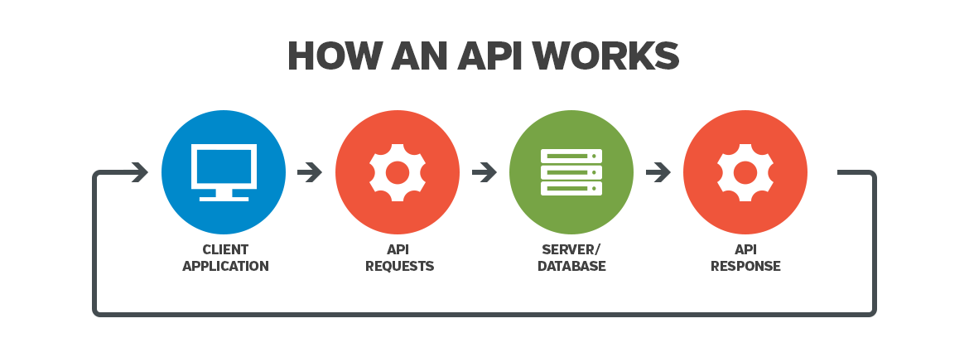

Figure 4-1 API explained

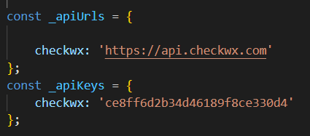

Figure 4-2 API key

* **Xampp**

This is the software used for the MySQL database, it provides a way for local host to test websites before completely releasing for the public. From Xampp it can open a phpMyAdmin page that allowed this project to build a database. The way that the weather forecast for aviation application uses PHP programming language to insert user inputted data and save it to the database.

## 4.2 Working procedure

Part of earning a pilot’s license requires the ability to decipher METAR data. CheckWXapi provides raw metar data most users will not be able to read this information. To counter this the project will use JavaScript to allow for a method to decipher this raw data.

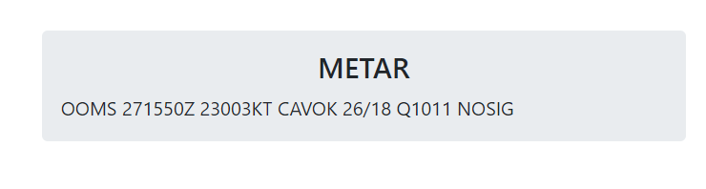

Figure 4-3 how metar data appears raw

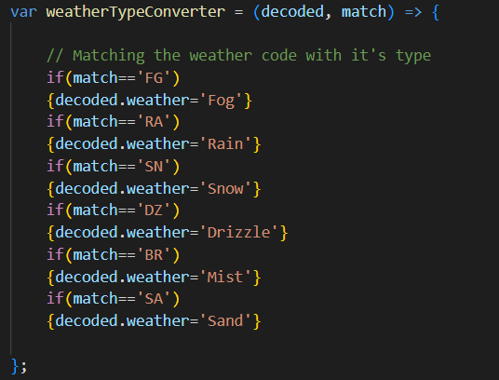

Figure 4-4match weather code with type

From the figures above, most people will not understand this, and showcase a little bit of the backend procedures that occur when the user chooses to decode the data. Furthermore, since the API will send data through a web link that is inserted in the JSON file. It requires a specific set of query rules that can allow user input to decide which data will be called upon. This is used to filter out the data from the API call and only send the required information set by the JavaScript code.

one of the objectives of this project is to gather real time weather data. This was accomplished using the CheckWXapi, in the METAR page of the weather forecast application the user can enter an ICAO code. This code is different for each airport, for example muscat international airport is OOMS, while London Heathrow is EGLL. Any time an ICAO code is entered it sends a request to CheckWXapi and displays it in the system.

In the weather map page of the system it shows a comprehensive weather map using Windy API. Which allows the user to customize Windy map visualizations in the weather map page of the project. the user can check a multitude of weather forecasts from any location using a single click. 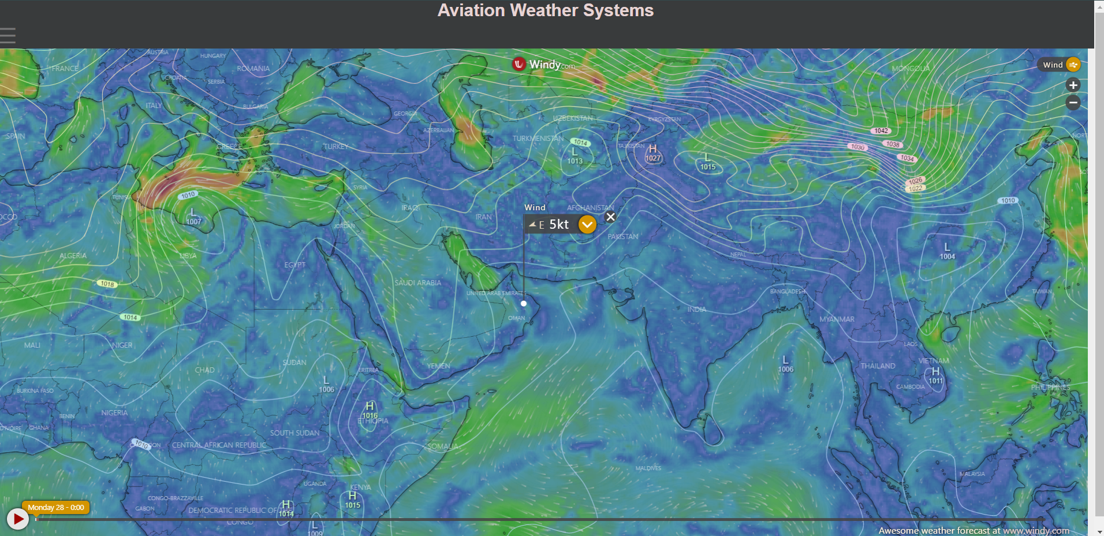

Figure 4-5 Weather map page

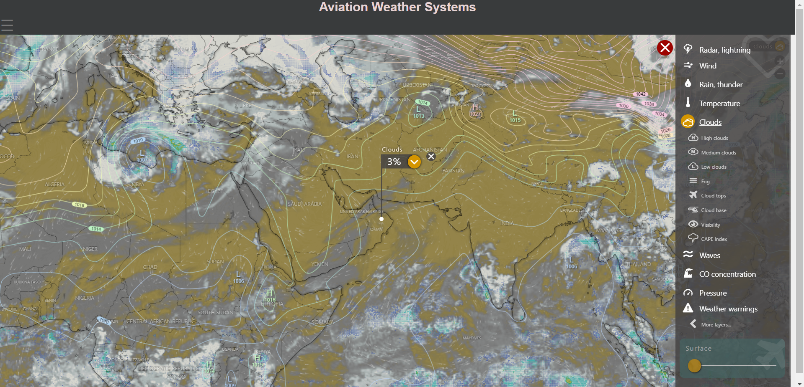

Figure 4-6 weather map functions

The user can check a many different weather forecast up to the next 9 days. While also they can choose from wind function to check wind speed in a certain area, clouds to check the level of CAVOK (cloud and visibility OK). This can help pilots prepare for their trips by informing them of what they might face on a flight.

The next page of the system that can be found using the navigation sidebar is the Airports page. This page uses Mapbox API to allow the project to draws the location of most airports around the world using Google Tags. Using this allows for the system to land an overlay over the map and give details regarding the any airport that was clicked on. Details such name, ICAO and description.

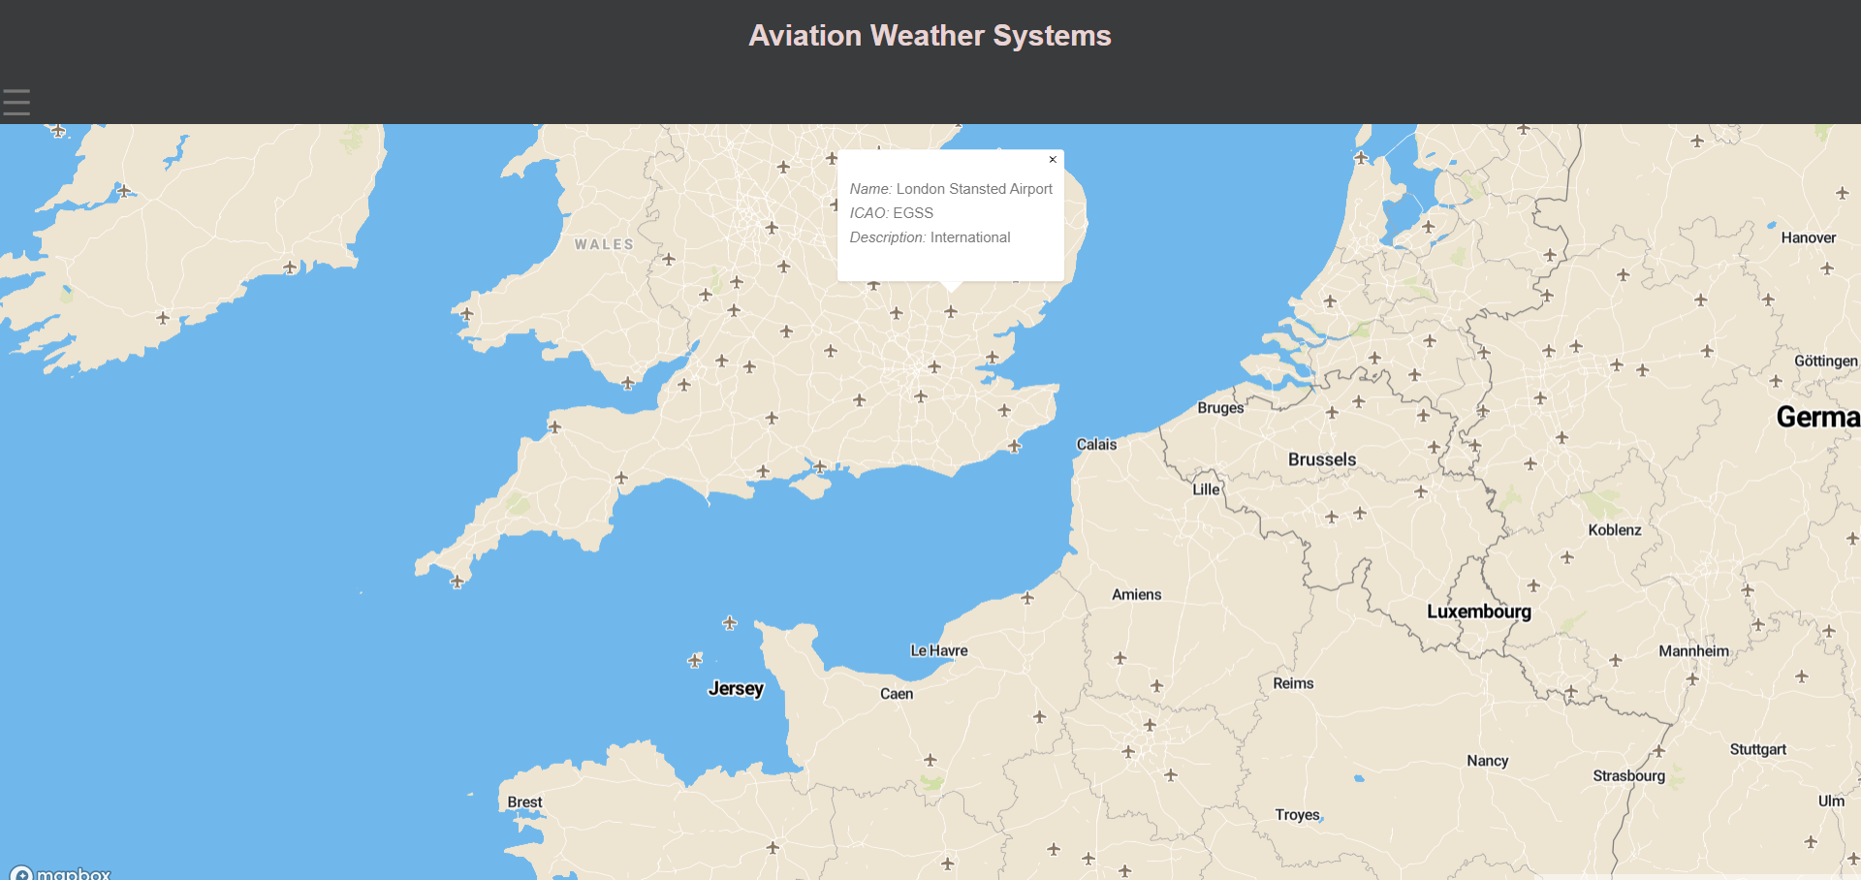

Figure 4-7 Airport map example

The next page is a live air traffic map, where the user can view live air traffic all across the world. To achieve this the project used google maps API and OpenSkyAPI where it can track and display this data. To link the HTML page with the API’s it needed javascript to execute a fetch request. A fetch request is a method where it allowed the HTML page to request data and place an icon at that location. Furthermore, each plane also includes an identifier.

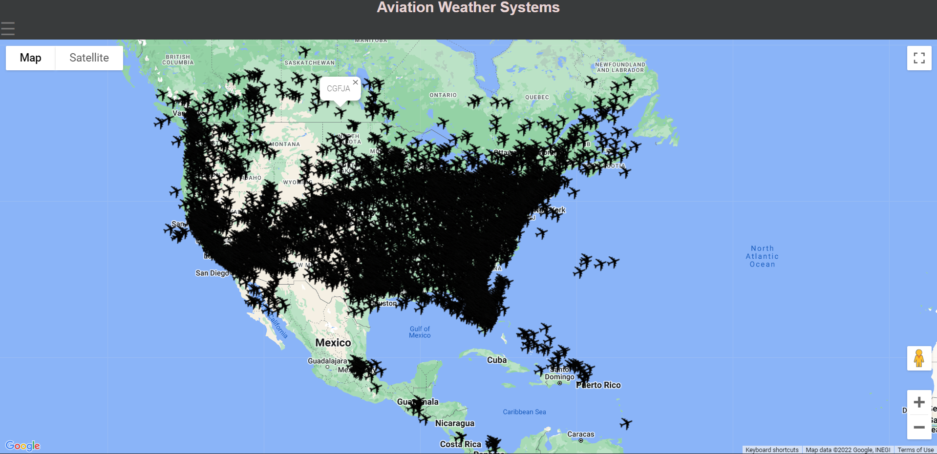

Figure 4-8 Live Air traffic

The next page is a registration page where user can input their username, email, and password and this data will be sent to the database located in phpMyAdmin. This is done by using Xampp which allows to create a local server to test these features. From there it requires a php page to allows the data to be recognized and sent to the database.

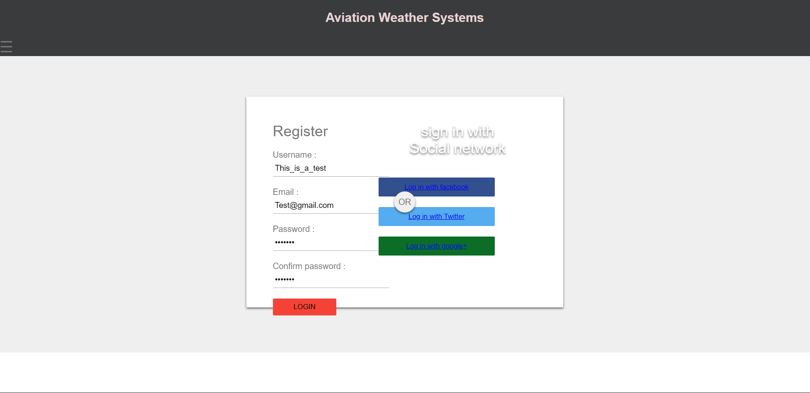

Figure 4-9 Sample Register

The final page is the fuel calculation page where the user can insert a set of data about the aircraft that they are using. Such as cruising speed and aircraft consumption to calculate how much fuel the aircraft would need to reach depending on the distance. Which also provides a calculation for which runway is currently active using the wind direction and the headboards at each airport. Headboards are used to quickly identify wind speed in Knots. 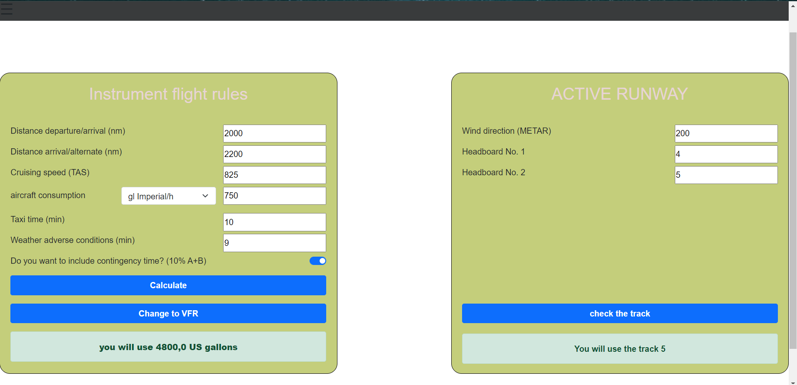

Figure 4-10 example of fuel calculation

## 4.3 Algorithm

Step 1: Start the system

Step 2: check Wi-Fi connection

Step 3: Load index page choose which page using side navigation

Step 4: Open METAR page from the side navigation

Step 5: User enters ICAO code of the chosen airport

Step 6: System requests the data from the CheckWXapi using the aid of ScriptM.js file

Step 7: Display the METAR and TAF data with airport name

Step 8: User can either read the data or choose to copy the data into the METAR decoder

Step 9: User copies and pastes in the decoder which then completes decoding and displays it as a JSON file.

Step 10: end or go to step 3 and choose another page

## 4.4 Site map

This site map shows all the web pages available in the system. This being done to show the front end of the aviation weather system and the inner workings behind it or the backend. It can show the relationship between each of the files of the system, since the UX (User experience) is important for the user it can help visualise what needs to work for the user to seamlessly use the Weather forecast for aviation system.

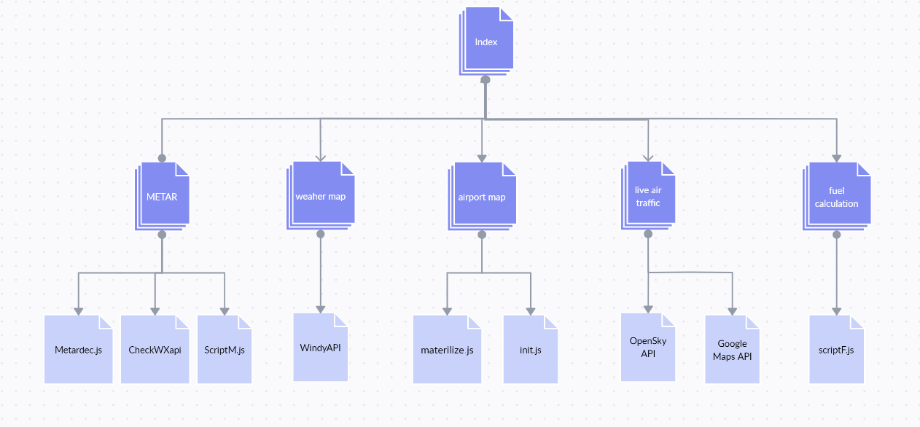

Figure 4-11 Site map

## 4.5 API/Webapp relationship diagram

The image below shows a simple explanation of the Aviation weather forecast system uses APIs to gather large amounts of weather data and display them in real time. For example, in the METAR page the user inputs the ICAO code and the client send a Get request to the CheckWXapi using JavaScript. From there the API call upon its database to receive that information and send it back to the client in a JSON format.

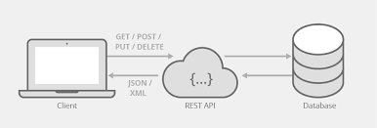

Figure 4-12 API/Webapp

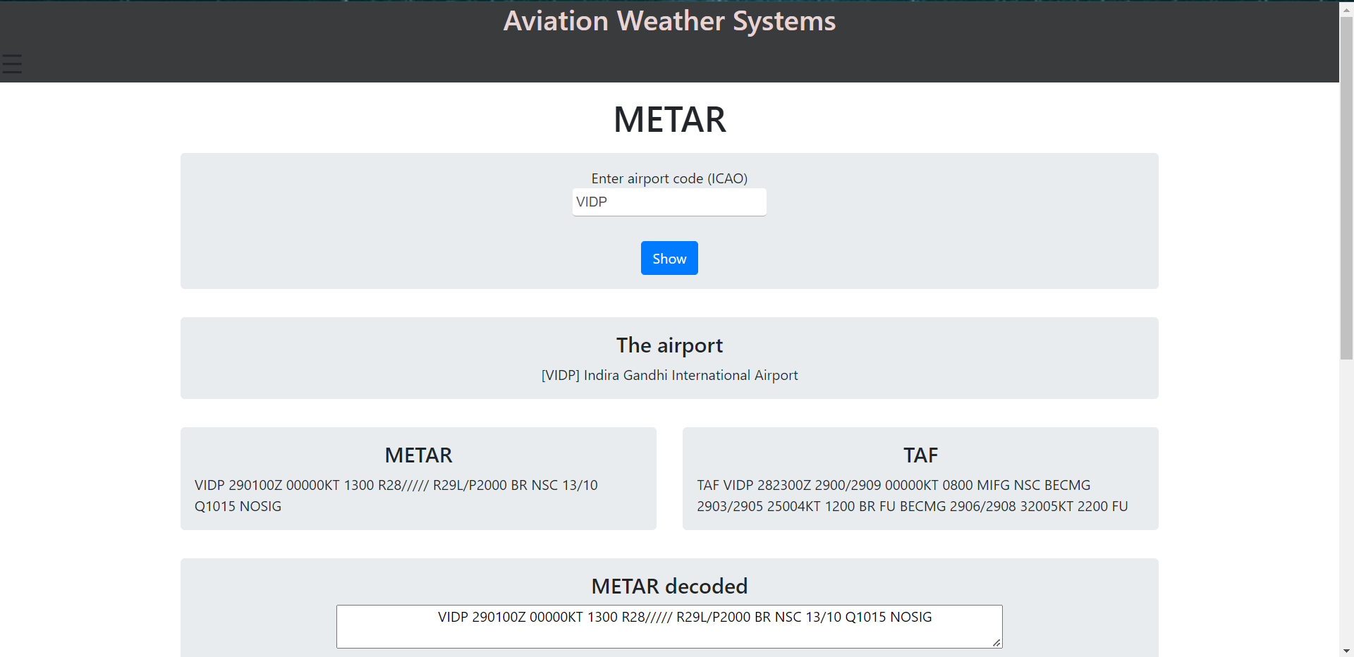

Figure 4-13 Example of Metar page

## 4.6 Project requirements

### 4.6.1 Software requirements

* Visual studio code
* XAMPP
* Google maps API key
* CheckWXapi
* Windy API
* OpenSky API
* HTML
* CSS
* JavaScript
* PHP script
* GitHub
* Windows operating system

### 4.6.2 Hardware requirements

* Laptop or desktop
* Internet connection

## 4.7 Software design

The software design of the project requires a comprehensive web application that can display concise data from other applications. Due to the nature of the application, it needs an easy to user interface, while maintaining the importance of the information that is displayed. Since there are multiple different programming languages used such as HTML, JavaScript, CSS, and PHP it needs a clear text editor to manage all of this. That is why visual studio code was chosen.

Being able to easily switch between pages and check for any mistakes while creating the application allowed for a more streamlined execution of planned objectives. While also there are extensions such as PHP debug. Html and JavaScript is integral in the creation of the connection between APIs and the web application. All software requirements used are further explained down below.

### 4.7.1 Windows operating system

This the most used operating system across the planet and has extensive support in all aspects there are so many coding languages and applications available for download. Windows OS allowed for visual studio code and the subsequent programming that followed.

### 4.7.2 Visual studio code

Visual studio code is a free programming code editor, it is one of the best available. It provided the project with a quick code-debug cycle, while creating the aviation weather forecast system it helped in allowing a quick transition between debugging and creating. Using this it allowed for these following to be easily implemented:

* HTML
* JavaScript
* CSS
* PHP

In this project JavaScript was used to connect the APIs to the web application while also allowing for complex formulas to be created to measure fuel calculations and decode METAR. While PHP was used to connect the HTML page to the MySQL database. CSS was used to create an easily digestible user experience.

### 4.7.3 XAMPP

XAMPP is an open-source web server solution. Its main use is to allow developers to test databases before deployment. Its use in the project was mainly to create a database using PhpMyAdmin then connecting with the project using PHP. It was used in the Register page that allowed username, email and password to be inserted in the database.

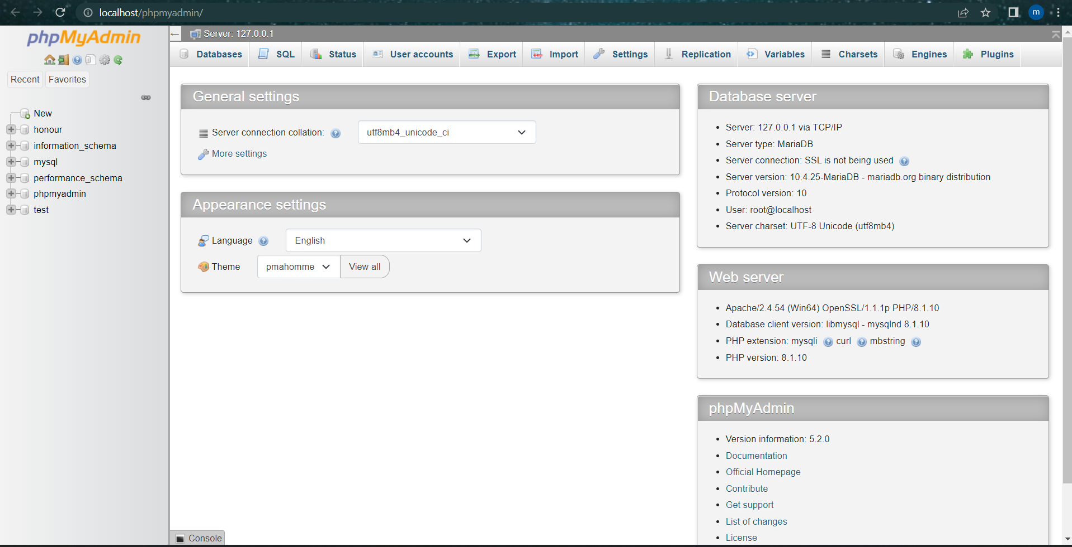

Figure 4-13 PhpMyAdmin

### 4.7.4 CheckWXapi

This is an API that gathers METAR, TAF reports in one database. As this API allows for accurate and real time weather data from all airports to be accessed instantly, it is one of the most vital parts of the project. To access this API it requires as most APIs do a key which was received through the account. As this was free it can only take 3000 calls to the database.

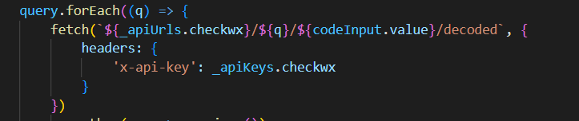

Figure 4-14 JavaScript code to send Fetch request to API

For the system to be able to query the CheckWXapi it needed the URL and API key to be a const variable. This means that this variable can not be changed, more will be explained in the following chapter.

### 4.7.5 Windy API

Windy API is a great weather map API that allows for its map to be inserted in any website using its URL. From there it can be edited to include certain values such as Cloud height, Visibility, and many more. This provided additional functionality to the weather map page while also allowing for simpler viewing of specific weather attributes.

### 4.7.6 Google Cloud

Using google cloud’s developer tools allowed for Google maps API to be added to the system this provided major functionality to the Live air traffic page and Airport map page. For this to be accomplished it needed to get an API key.

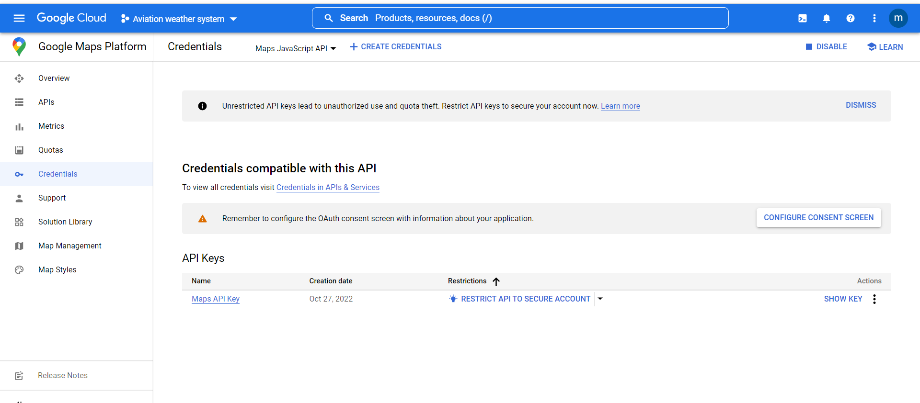

Figure 4-15 google map API key

### 4.7.7 OpenSky API

OpenSky is open-source air traffic surveillance API, using this in conjunction with Google maps allows the location of all tracked flights to be tracked. It connects the application to the OpenSky network, it uses the Fetch method in the project to get all this data of live air traffic and overlays it on the map. While also providing the ID of each tracked plane.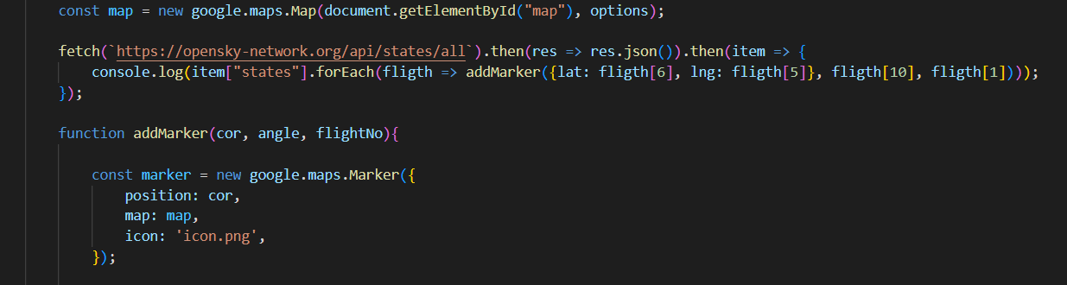

Figure 4-16 OpenSky API in Project

### 4.7.8 GitHub

GitHub is an open-source community where developers from all over the world share their projects and solutions to coding problems. This was used In the airport page to gather google tags for the airport descriptions and locations.

## 4.8 Project Cost

|  |  |  |  |  |
| --- | --- | --- | --- | --- |
| **No** | **Component name** | **Quantity** | **Price total in Omani Rial**  **(OMR)** | **Totol cost in Omani Rial (OMR)** |
| **1** | Xampp | 1 | 0.000 | 0.000 |
| **2** | Google Map API | 1 | 0.400 | 0.400 |
| **3** | OpenSky | 1 | 0.000 | 0.000 |
| **4** | Windy | 1 | 0.000 | 0.000 |
| **5** | CheckWX API | 1 | 0.000 | 0.000 |
| **Total Price of Components** | | | | 0.400 |

Table 4-1

## 4.9 Summary

This chapter should have covered all the main aspects relating to the design of the project. it briefly explains how each page should work while including all components required for that to happen. While mentioning the important software components of the project such as the google maps API and CheckWXapi. It also explains why each of them was used and how it was linked together. A site map was also provided as it gives a brief overview of the frontend of the system while showing what scripts were use for the backend of each page. Whereas it also explains the interaction of API with the Aviation weather system. A project cost table was added to show how the component cost of the project, it cheap due to most APIs limiting the amount of calls a web application can make to the API’s database.

# Chapter 5 System implementation and testing

The chapter will illustrate how the Aviation weather system was created and implemented. It focuses on the process that allows user input in the system to contact the API and receive the data. While also this chapter should explain what steps would be taken to test the system. the testing steps will also be explained in each of the necessary pages. Furthermore, it will show how some of the difficulties regarding the connection with some of the APIs and the client side. While showing how some steps were taken to resolve or circumvent these issues. The Aviation weather system was coded in visual studio code using HTML, JavaScript, CSS and PHP to achieve the project objectives. Using JavaScript allowed for the project to connect the various APIs and HTML and CSS was used to display and present the data.

## 5.1 Software implementation

The Aviation Weather System was programmed in visual studio code which is a text editor. Using HTML and CSS allows for all the data to presented in a simple and effiecent manner. While JavaScript allowed for the project to connect to APIs such as CheckWXapi which was used in gathering accurate weather information from all ICAO registered airports. PHP was used in conjunction with HTML to input user entered data into the register database. XAMPP allowed local server testing without deployment using PhpMyAdmin.

### 5.1.1 Software installations and database

The first step in software implementation is to install visual studio code and XAMPP. Any text editor can be used to view the inner working of the system but visual studio code is recommended. After installation of XAMPP version 8.1.12 and insert the weather aviation system zip or in whichever format in htdocs folder of XAMPP and make sure to extract the file it should appear as the following image.

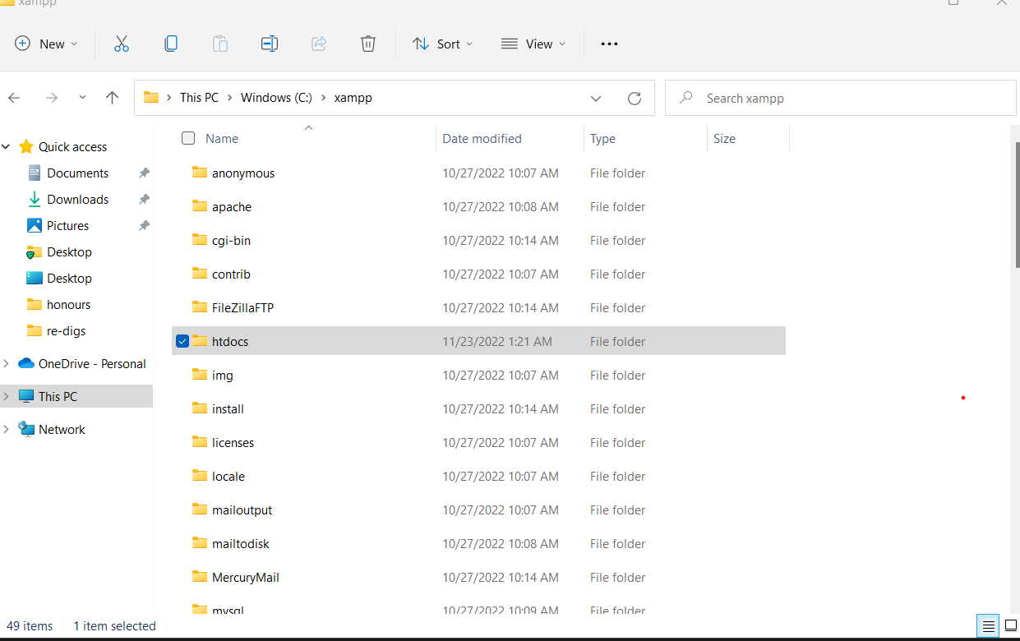

Figure 5-1 htdocs location

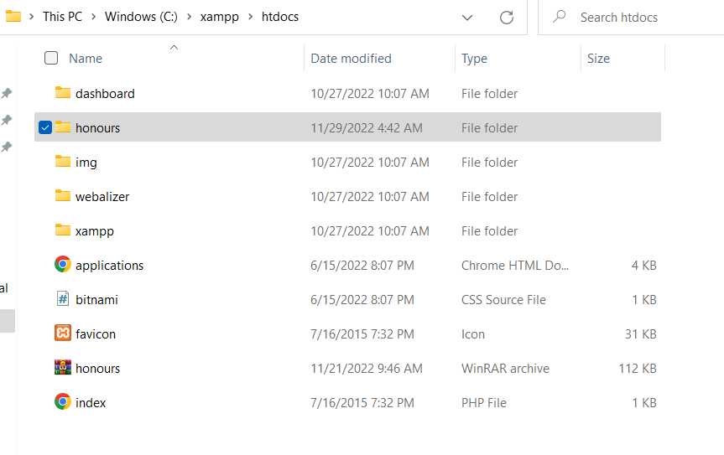

Figure 5-‎0‑1 inside htdocs

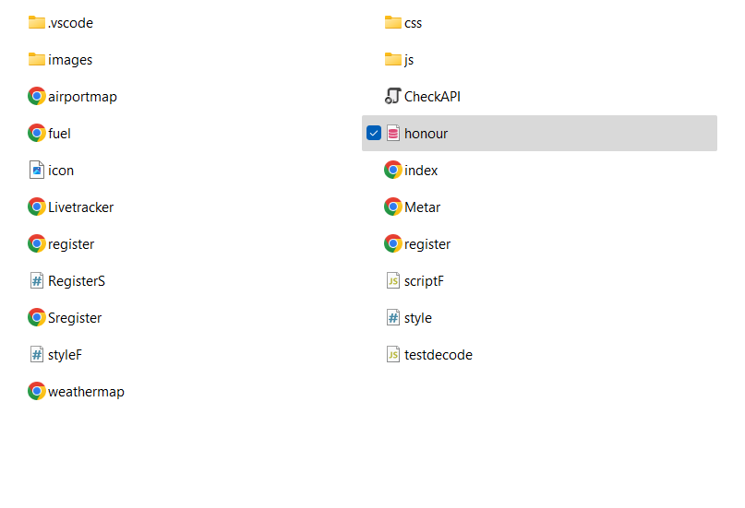

Figure 5-3 image of aviation weather system files

The files need to be in this location for the application to work properly as it pertains to the database connection. To start the application first open XAMPP Control panel press start on **Apache and MySQL**, from there press admin in the MySQL row to open PhpMyAdmin. From phpMyAdmin select import and choose honour.sql file, this should add the database automatically.

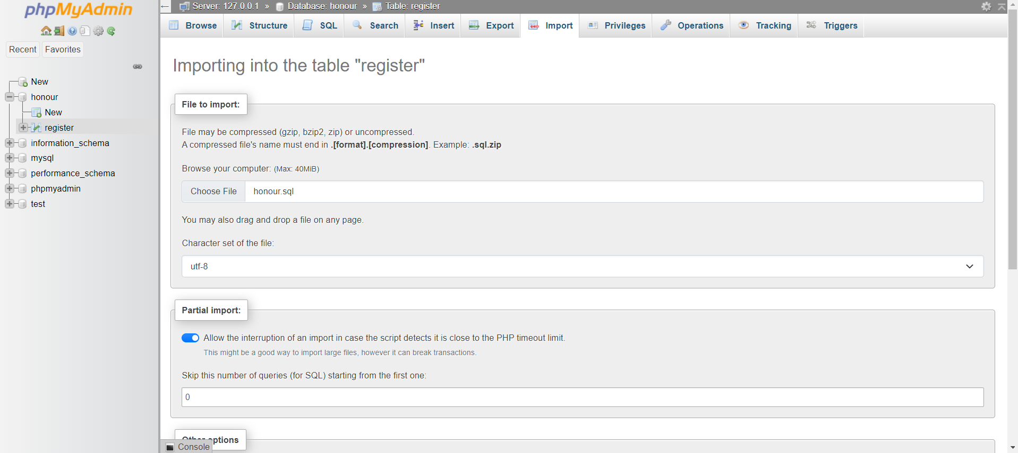

Figure 5-4 phpMyAdmin import database

Make sure that the database name is the same in Register.php file on line 14.

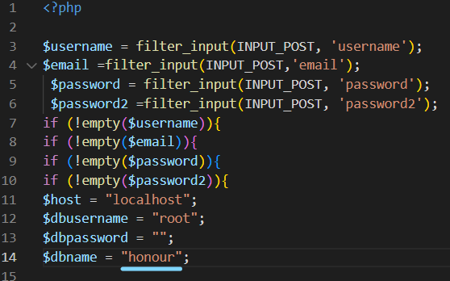

Figure 5-5 register.php database name check

### 5.1.2 Web page

If all the steps were followed the application can be started. Enter in search bar of the chosen web browser.

* http://localhost/honours/index.html

the application should open and present the home page. In this page is the side navigation bar that is available across the entire system. while featuring some explanations of what the application can do.

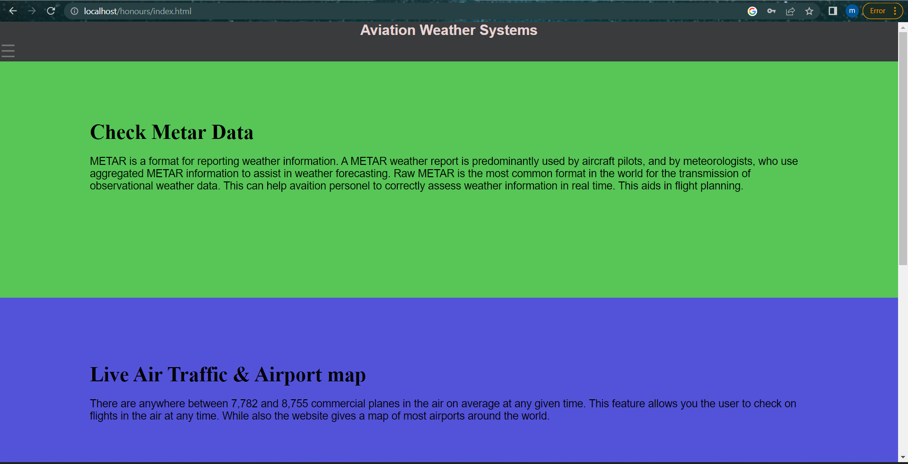

Figure 5-6 Index page

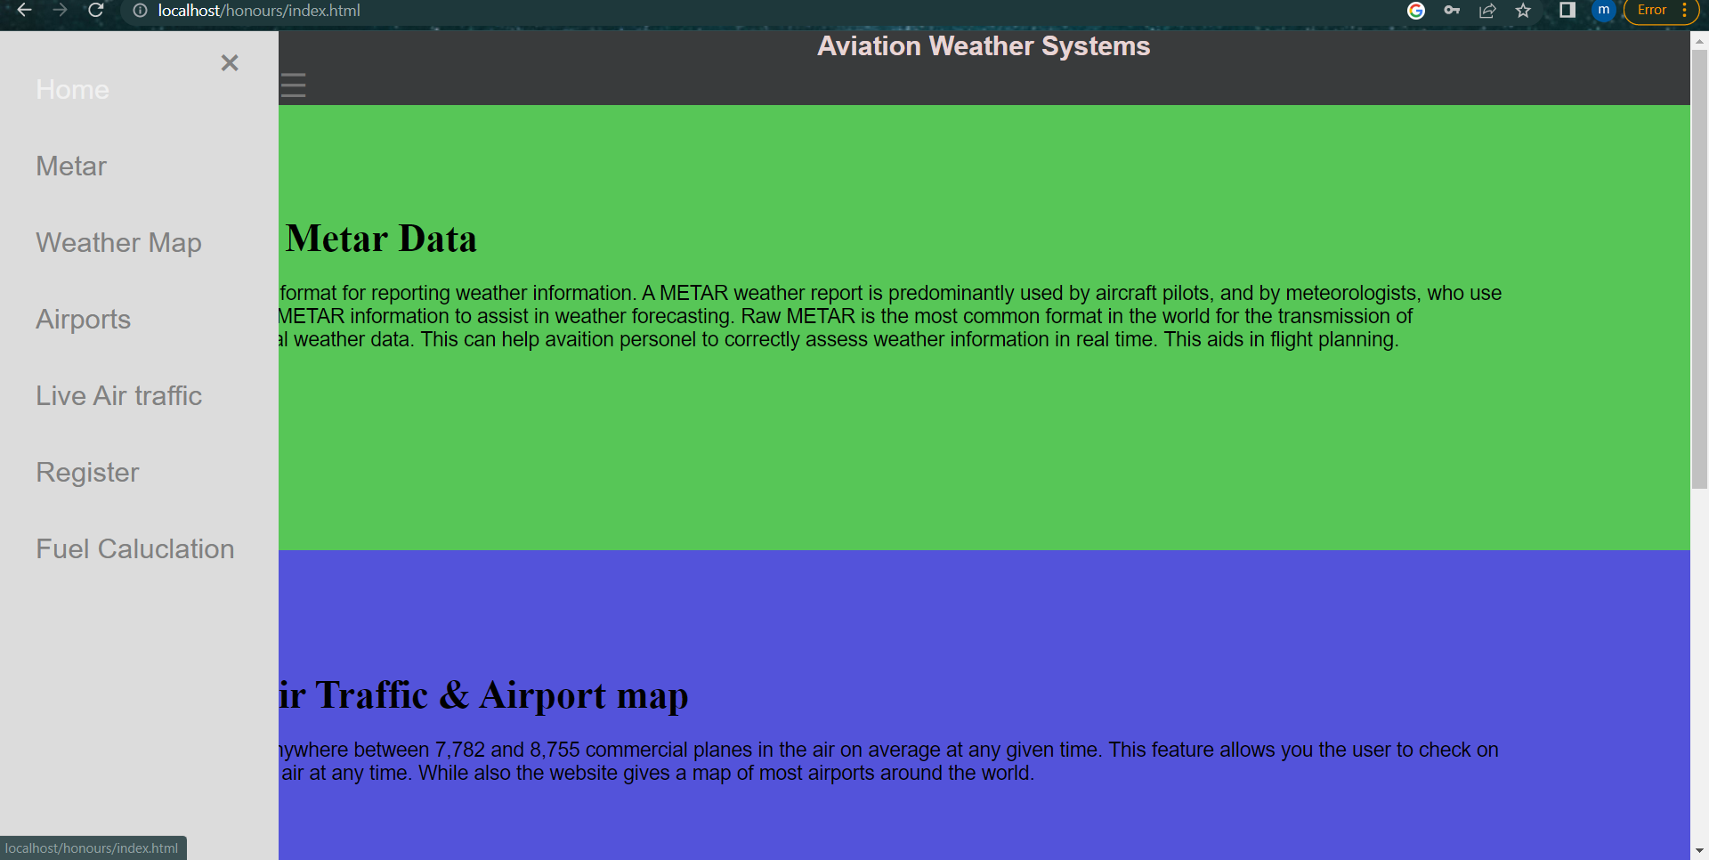

Figure 5-7 Side bar navigation

### 5.1.3 METAR page

This page is one of the most important in the application. It uses CheckWXapi to gather real-time airport METAR and TAF data, it can call up to 3000 times a month due to the free nature of the API key. It uses two different JavaScript files named script.js and testdecode.js to complete the required operations.

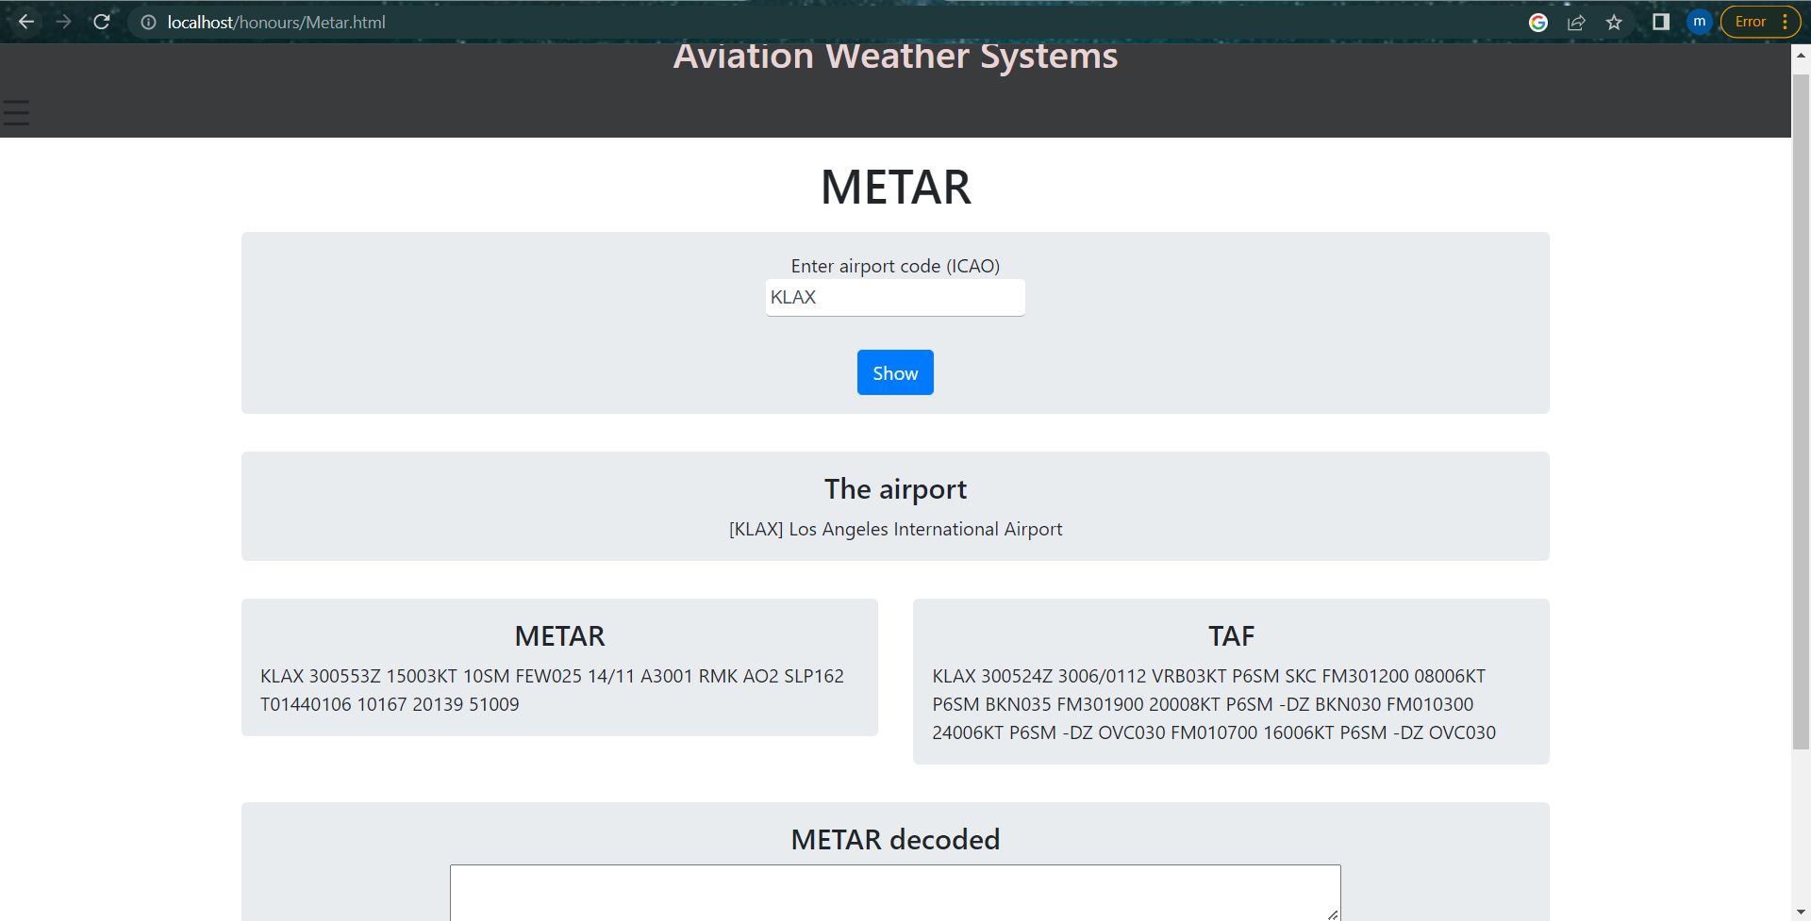

Figure 5-8 ICAO+ Metar

To connect the application to CheckWXapi and get the weather data, it uses the scriptM.js file and the code within it to do so. Usually, to get the data it would need for a URL with the ICAO code within it to fetch the data. An example of how the Get request is used to contact the API is shown below.

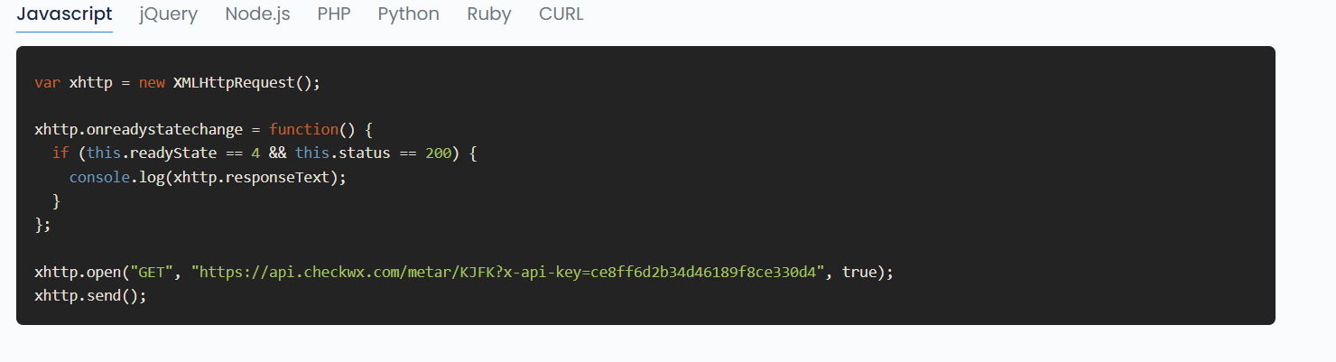

Figure 5-9 CheckWX API source example

But this only allows for a specific request to be sent the API for this reason some JavaScript code had to be implemented to circumvent the issue. In this instance it would require the ICAO code to be made into a user inputted value. To do this required HTML code mainly input class, and this was linked to script.js file.

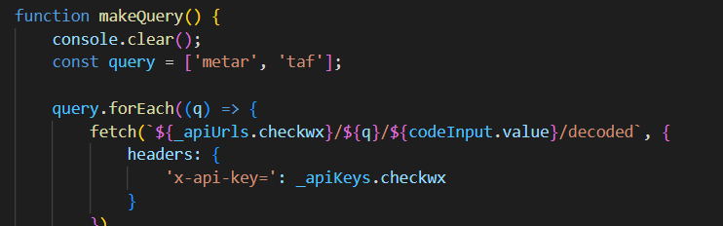

Figure ‎0‑2 checkwx api user input

After already adding the API key and URL it was rearranged to complete the objective of gathering weather data using user input. this then uses sends the real time airport and METAR data straight to the user after calling the CheckWXapi.

To display this data it needed for the values received from the API to be given variables. This allows for the METAR report to be presented back to the user. This project used const to declare variables as const does not allow the variable to be changed in under any circumstance. Const was used as it gives a read-only value.

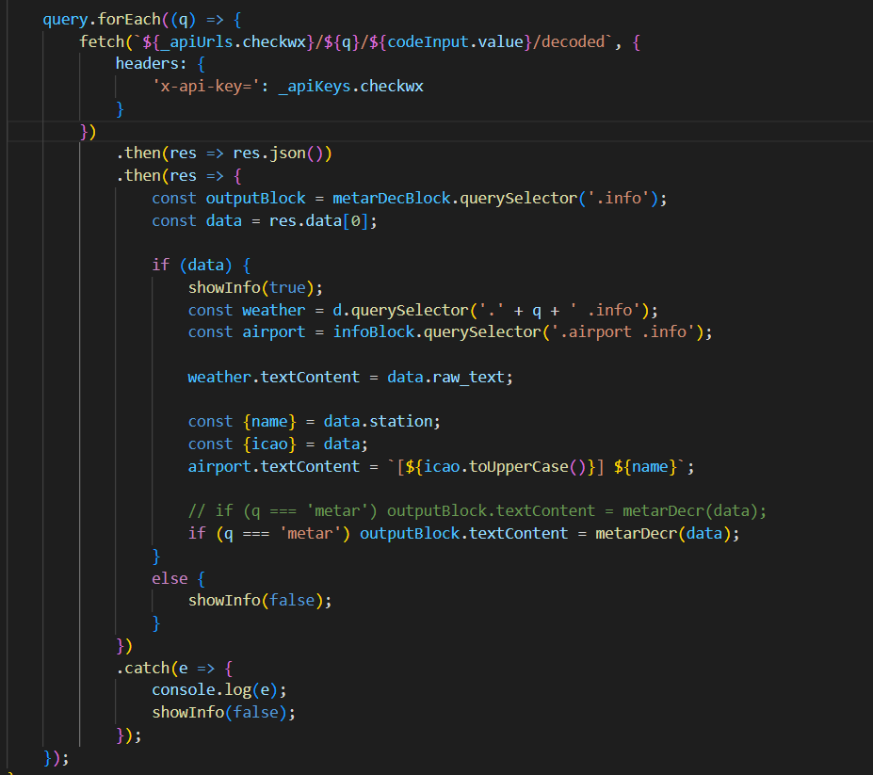

Figure ‎0‑3 const METAR

The API should allow for decoded METAR data to also be called for but was not working for the project. for that reason, another method was required to decode the data, to fix the issue METAR decode was built and inserted in the same page. To correctly decode the data some comprehensive study was undertaken to accurately understand and decode the data. Pilots are required to have the ability to read raw METAR data it is part of the requirements to gain a pilot’s license. The figure below should give a basic understanding of the parameters needed to create the METAR decoder section of the page.

# 

Figure ‎0‑1 METAR raw decoded example (Perlman, 2016)

Testdecode.js script identifies such abbreviations and correctly labels them for example RA is rain and DZ is drizzle.

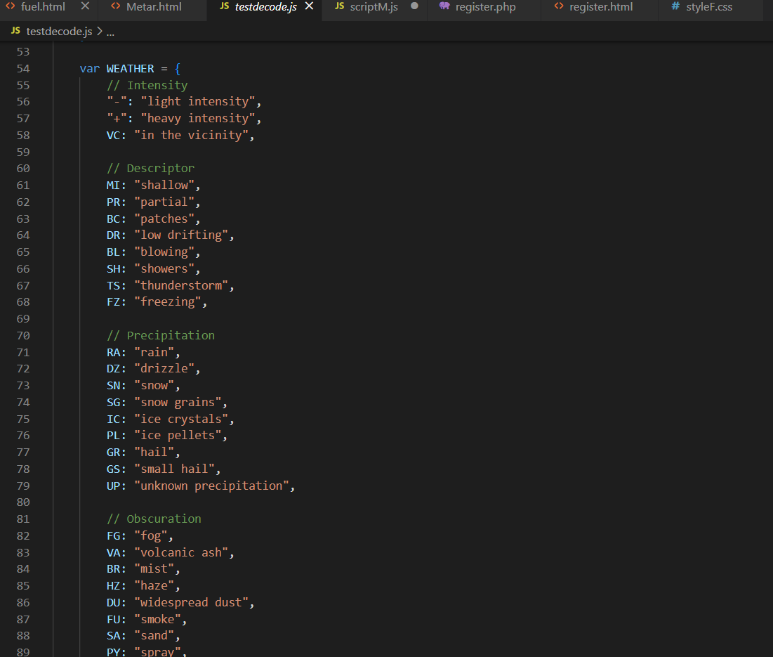

Figure ‎0‑2 testdecode.js METAR identifiers

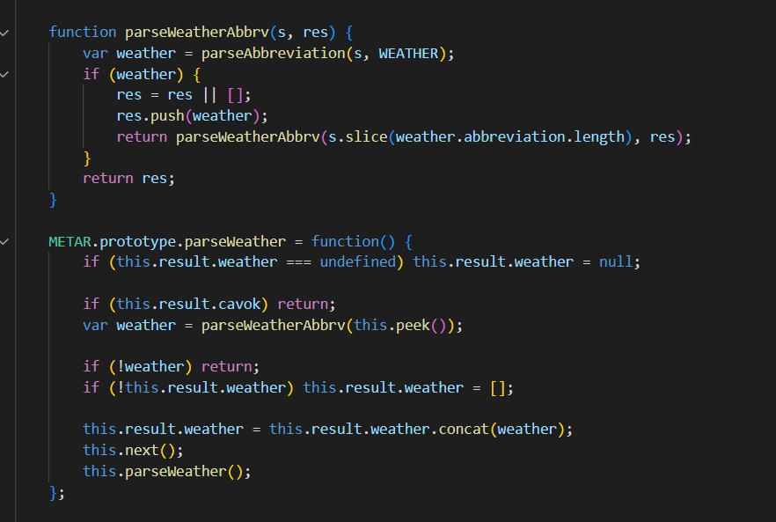

Figure ‎0‑3 testdecode.js return weather example

Many other vairables are recorded in the file as it should be able to determine other factors such as CAVOK (cloud and visibility OK) and Wind speed.

If the user wants to decode the data, they should copy the METAR data gotten from CheckWX API and paste it in the METAR decoder bar and press parse. The following is an example of decoded METAR data at [VIDP] Indira Gandhi International Airport.

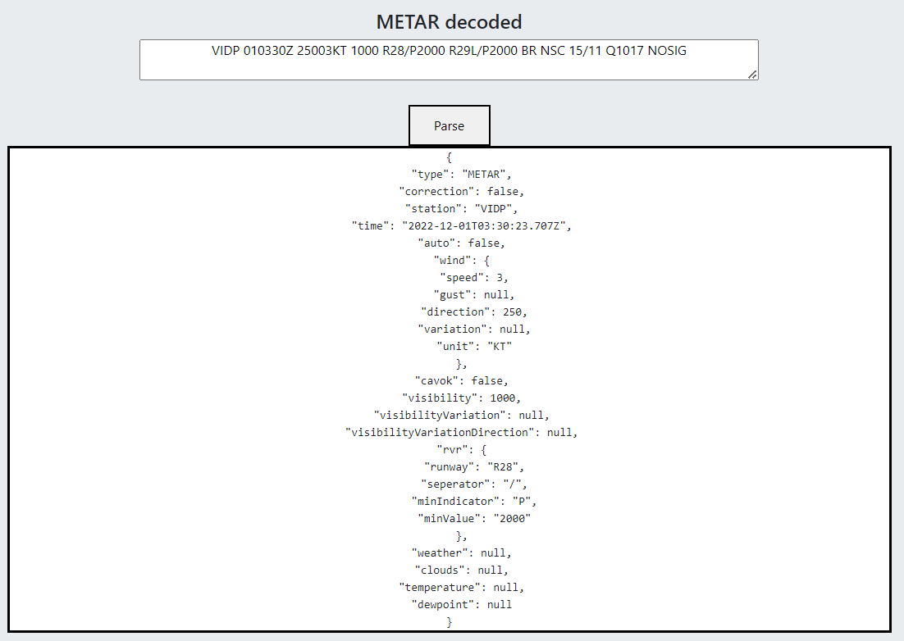

Figure ‎0‑4 Decoded METAR VIDP

As the user inputs the METAR data it will present them with the decoded METAR data. With all the data provided by that airport being decoded. the testdecode.js script returns the decoded data as JSON. This created an easier to consume method for the user, as it lowers the possibility of mistakenly reading the raw METAR data.

### 5.1.4 Weather map page.

This page uses Windy API to insert a weather map that has a variety of functions such as wind speed and direction, high/low cloud, and visibility. This provides a simple yet functional way for the user to get specific weather details. it did not require much effort to display this map onto the web application just a URL. This page was created to allow for easier use of the application which can encourage the user to keep using the website.

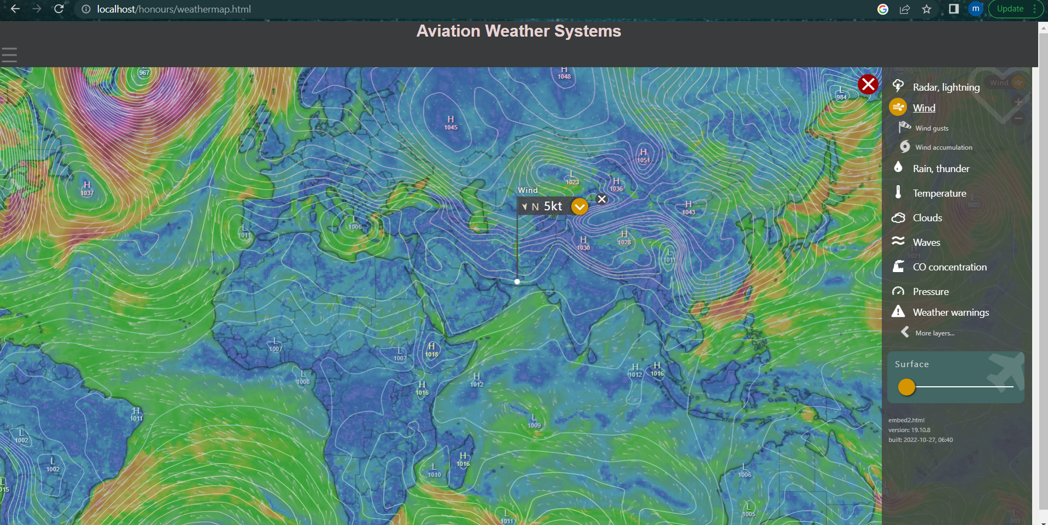

Figure ‎0‑5 Weather map page



Figure ‎0‑6 Windy API

### 5.1.5 Airports page

This page uses MapBox API and Google tag manager to display a map that has an overlay of tags, which shows airports around the world. Most of the airports around the world are displayed and the user can click on them to get information on that specific airport. It will show simple data such as ICAO code, name of the airport and a basic description which identifies what type of airport it is. this page used GitHub to get the google tags as it required a business to be able to set up. GitHub’s open-source community allowed for this page to exist in this fashion.

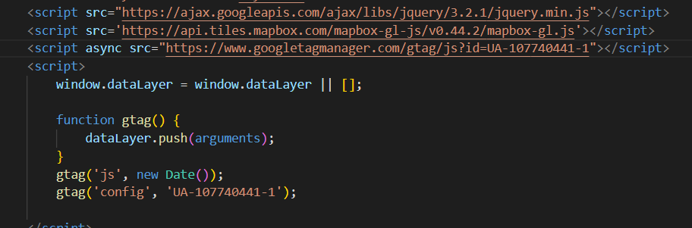

Figure ‎0‑7 Airport map Google Tag

### 5.1.6 Live Tracker page

The aim for this page is to use OpenSky API to gather flight data from thousands of flights and display them. The map that was used to overlay the live air traffic is Google maps API. The page was made intending to allow the user to view any airborne commercial flight. If the user clicks on a certain flight, it provides an identifier for the flight.

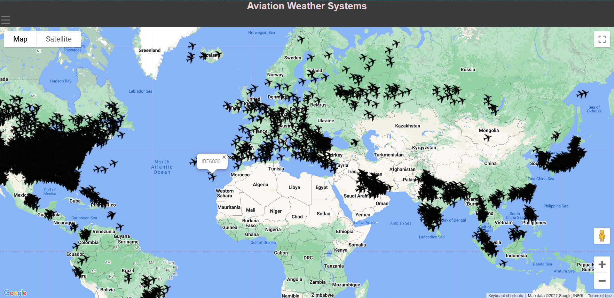

Figure ‎0‑8 live air traffic example

the map is centered around Istanbul, turkey as it provides an accurate center. the way the page works is the page is connected to OpenSky API and then uses a fetch request to get the location of the flights. From there, using the data gathered it overlayers the location with an image. While also giving information in that location gathered from Opensky.

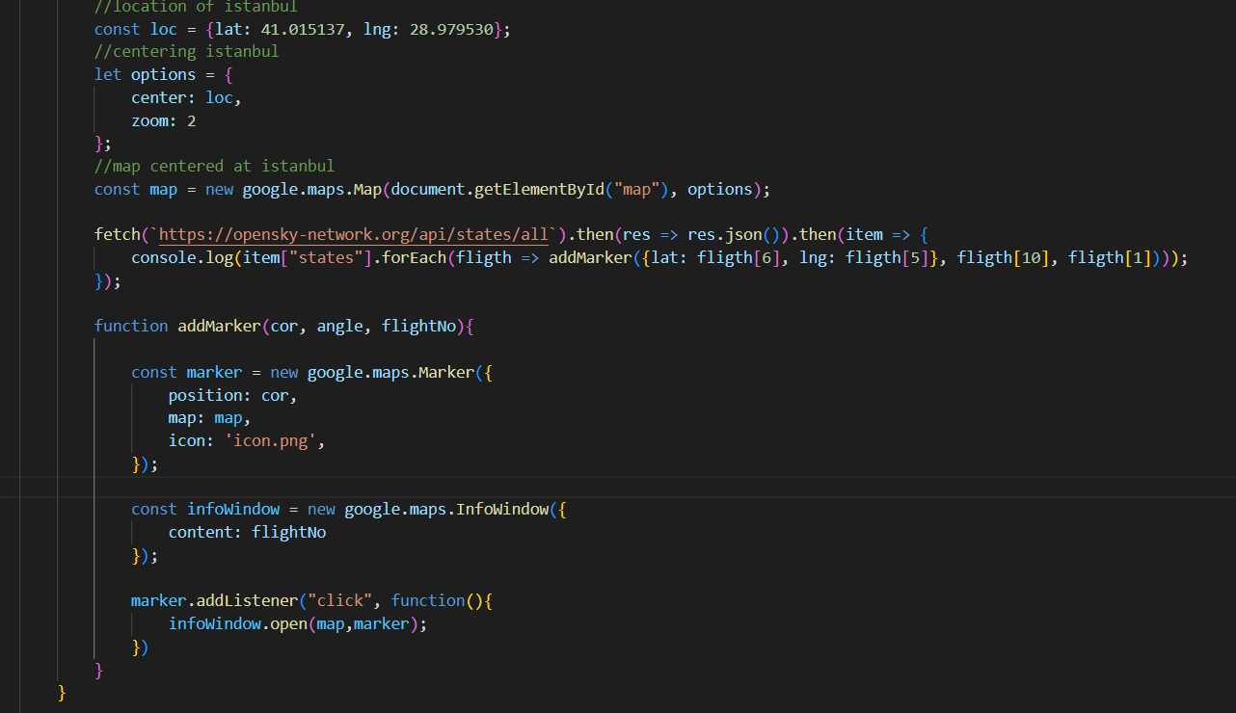

Figure ‎0‑9 Fetch request Live air traffic page

The improvements that could be made to the page is that the flights image is all pointing the same direction. This is due to the API not giving the direction of the flight, this could be improved using another API or creating an image that could be rotated automatically.

### 5.1.7 register page

Furthermore, the register uses XAMMP and PhpMyAdmin to insert user inputted data into the honours database. This uses an html connected to a php page to insert certain variables into the page.

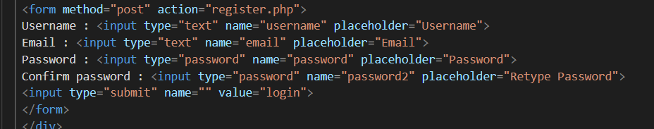

Figure ‎0‑10 register HTML

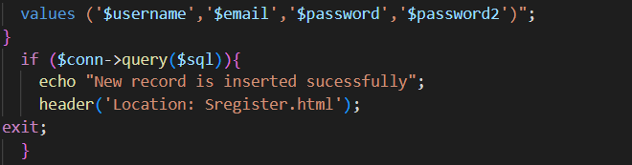

Figure ‎0‑11 register PHP

### 5.1.8 fuel calculation page

This page uses JavaScript to create a formulate to calculate fuel usage depending on distance and weather conditions. While also providing a runway check for airports, this shows which runway should be used. There are two different flight rules that fuel calculation is based on IFR (instrument flight rules) and VFR (visual flight rules). Depending on the weather conditions a pilot may choose between these sets of rules. in this page depending on the chosen set of flight rules the user can calculate fuel consumption of a vehicle using Distance, cruising speed and aircraft consumption per hour and others.



Figure ‎0‑12 IFR form

The html page is connected to the scripF.js file to run the calculations. The following is for IFR.

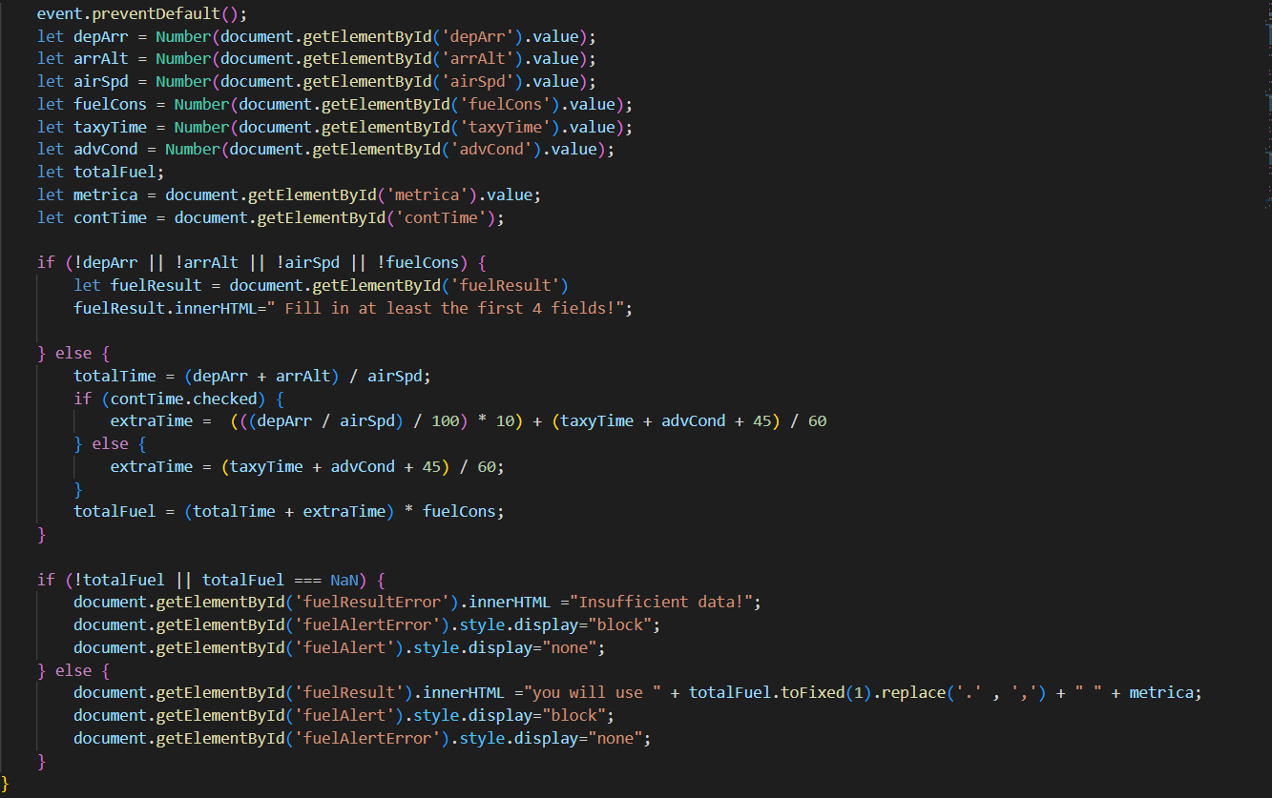

Figure ‎0‑13 IFR code

## 5.2 System testing

The aviation weather system was created to aid pilots in gathering weather information and providing tools to increase safety. the application was made to gather real time weather data to aid in flight safety. to test the system accurately regarding real time weather data it will be compared to other applications of similar nature mainly the METAR page. Data from 5 different airports will be used to test the METAR function of the aviation weather system. As this project focuses on creating tools to aid flight path safety it is important that weather data is gathered quickly and accurately.

The METAR page tests will use 5 separate airports and gather their data while also comparing data gathered from other applications. It will test two aspects of the page the decoder and the CheckWX API linked fetch request. For one of the tests, it will rival the results against METARreader.com. This being done to understand how accurate the Aviation Weather System METAR reports and decoder are.

The five airports chosen to be tested are KJFK (John F. Kennedy International Airport), OOMS (Muscat International Airport), RJTT (Tokyo International Airport), EGLL (Heathrow Airport) and VIDP (Indira Gandhi International Airport). The test for KJFK will compare the METAR data gathered by both applications and will include the decryption to compare between the results for one airport.

### 5.2.1 KJFK METAR test

This is data from KJFK using the aviation weather system. It instantly provides the raw weather data from the chosen airport providing both METAR and TAF information.

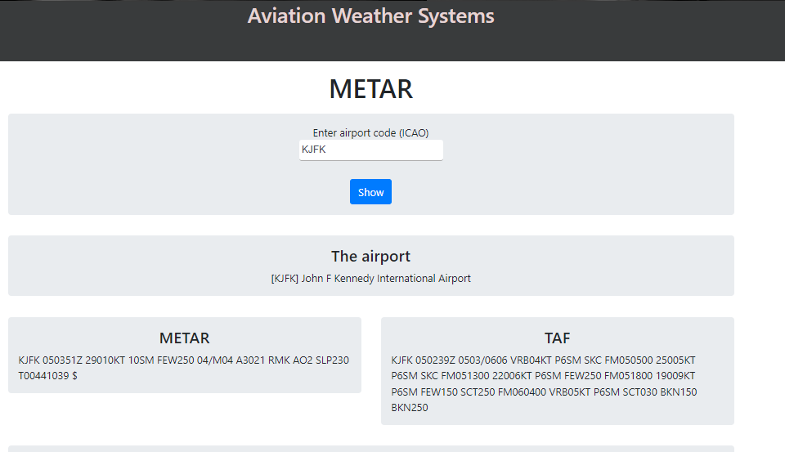

Figure KJFK raw test

when checking the given report from METARreader.com it provides the same information on both applications.

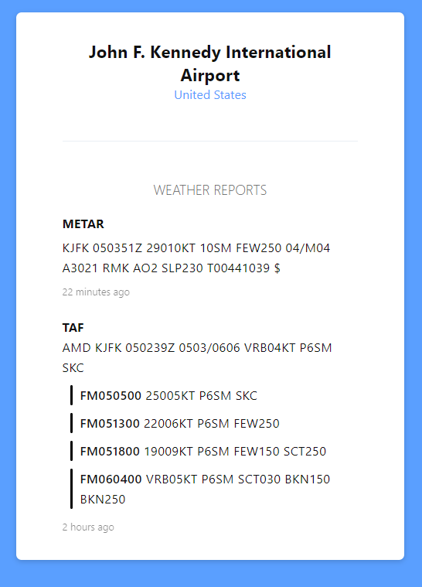

Figure METARreader.com raw KJFK

When the user enters the raw data into the aviation weather system decoder it gives out the following result. While METARreader.com provides the same information showing that the system is accurate and functional.

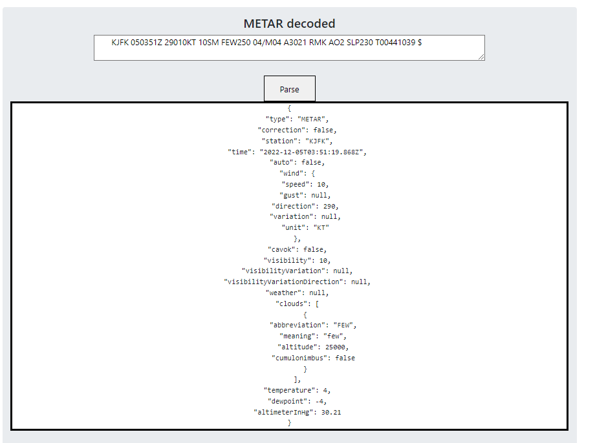

Figure KJFK decoded test

From the decoded data the system uses the testdecode.js file to decode the raw metar data. The decoded data indicates the time data was recorded and when it was decoded. The speed of wind which is 10 knots and the direction its coming from which is 290 degrees. Then onto cloud and visibility, CAVOK is false at this airport meaning that pilots cannot view more than 10km ahead and there are no clouds below 5000 feet. it basically means that visibility is not ideal. While also it determines that the temperature is at 4 degrees Celsius and dewpoint is -4 degrees Celsius.

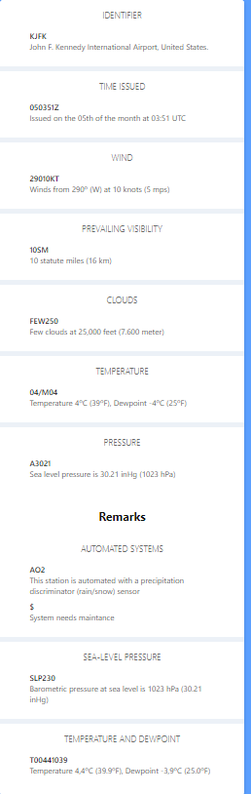

Figure METARreader.com decoded KJFK

The METAR decoder function of the application works well providing and decoding the raw data accurately. The only visible difference is the METARreader.com decoded data provides the temperature in decimals while the application provided with no decimals. Furthermore, the aviation weather system provides the status of CAVOK (cloud and visibility OK) while the other application does not. The report gathered using JavaScript and CheckWX api is accurate in this test. While the decoder function of the page works as intended to provide revealing data regarding the weather in the surrounding region of John F. Kennedy International Airport. This provides pilots that are flying with information to aid in the safety of their passengers and themselves.

### 5.2.2 OOMS METAR test

Muscat international airport (OOMS) is also tested using the METAR page of the application.

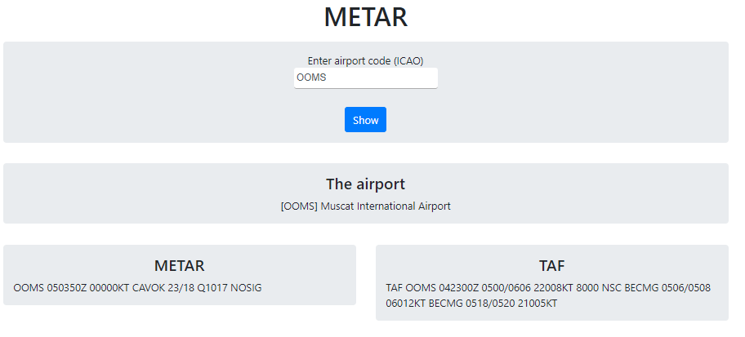

Figure OOMS raw test

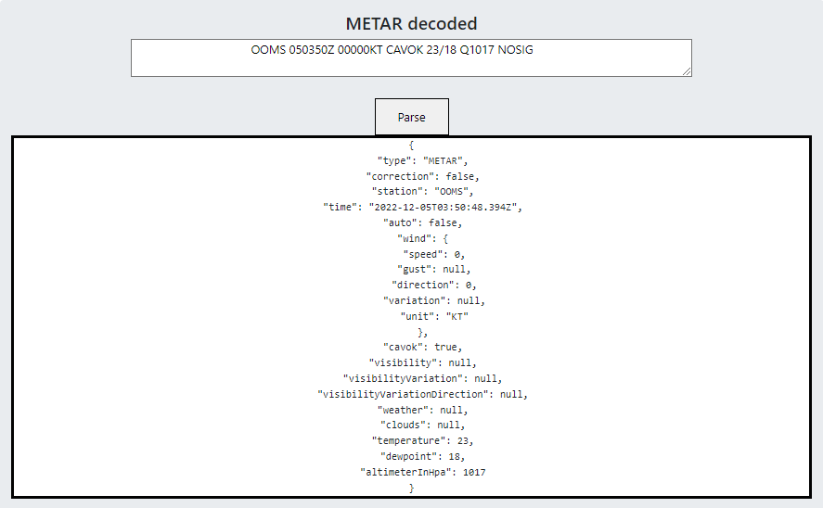

Figure OOMS decoded test

From the data retrieved in the system it can be seen that the raw METAR and TAF is provided. The decoded data shows the name of the station and time of report being retrieved. The speed and direction of wind is 0 knots and 0 degrees meaning that there are calm winds. CAVOK is true meaning pilots can see above 10 km with no Cumulonimbus clouds and no clouds below 5000 feet. Temperature and dewpoint are 23 and 18 degrees Celsius. Furthermore, pressure is 1017 hPA. From the raw METAR data it can also be seen that NOSIG is also reported meaning no significant change in weather for the next 2 hours at least.

### 5.2.3 RJTT METAR test

RJTT is the ICAO code for Tokyo Haneda international airport. Using the fetch function in script.js file it gathered the METAR data for the airport.

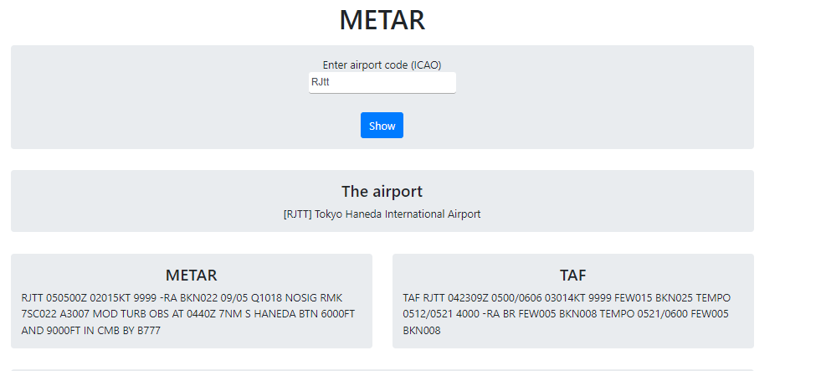

Figure RJTT raw test

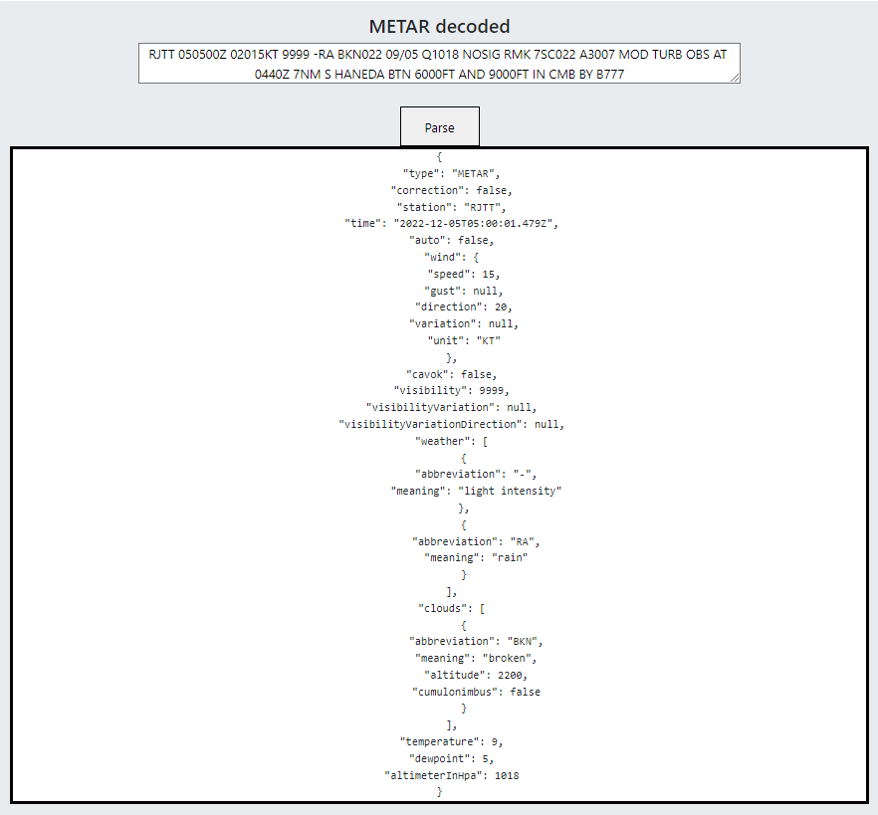

Figure RJTT decoded test

From the raw METAR and TAF data it can be seen that there are more weather conditions affecting Tokyo Haneda international airport. The decoded data includes and decodes more due to the inputted data. From this data time and station is provided, with wind speed at 15 knots and the direction at 20 degrees. CAVOK is false even with visibility being more than 10km, this is due to broken clouds present at an altitude of 2200 feet. With rain present at the location surrounding the airport. No cumulonimbus clouds present. Temperature is at 9 degrees Celsius and dewpoint at 5 degrees Celsius, pressure is 1018 Hpa.

### 5.2.4 EGLL METAR test

EGLL is the ICAO code of London Heathrow airport, this is the busiest airport in the world.

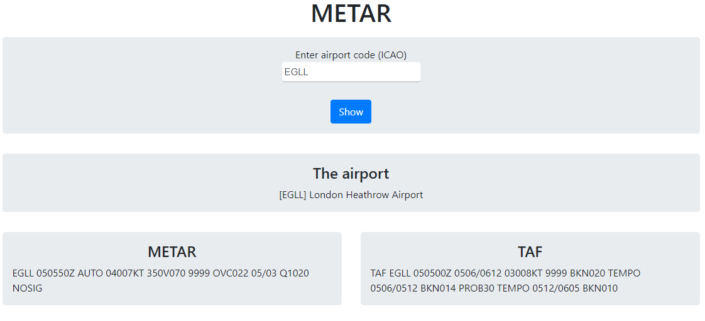

Figure EGLL raw test

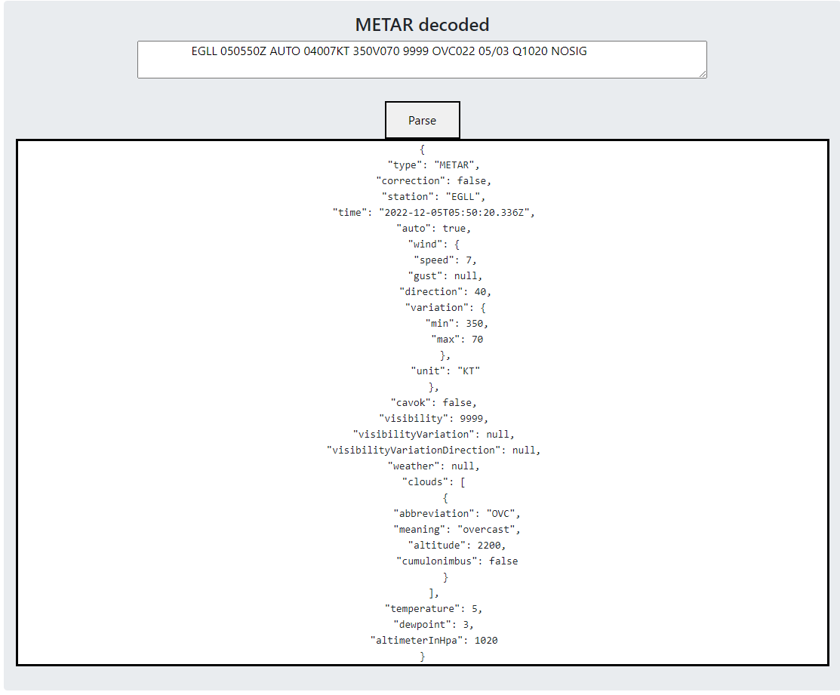

Figure EGLL decoded test

From the raw METAR test it can be seen that both METAR and TAF is provided fully. The decoded METAR shows the time of the report and name of the station while also including that this is an automated report due to auto returning true. Wind speed is at 7 knots and direction is 40 degrees. This report also includes variable wind direction meaning that wind direction can change during this time and this is at a minimum of 350 degrees and maximum of 70 degrees. CAVOK is false even though the visibility is above 10km or more. This is due to the report showing that the area is overcast shown by OVC in the raw report it is also shown in the decoded function. Clouds are at an altitude of 2200 feet. Temperature is at 5 degrees Celsius and dewpoint at 3 degrees Celsius and pressure is at 1020Hpa. In the raw report it has NOSIG abbreviation meaning that no significant weather change is expected in the next two hours.

### 5.2.5 VIDP METAR test

VIDP is the ICAO code of Indira Gandhi International Airport. The report returns both raw METAR and TAF.

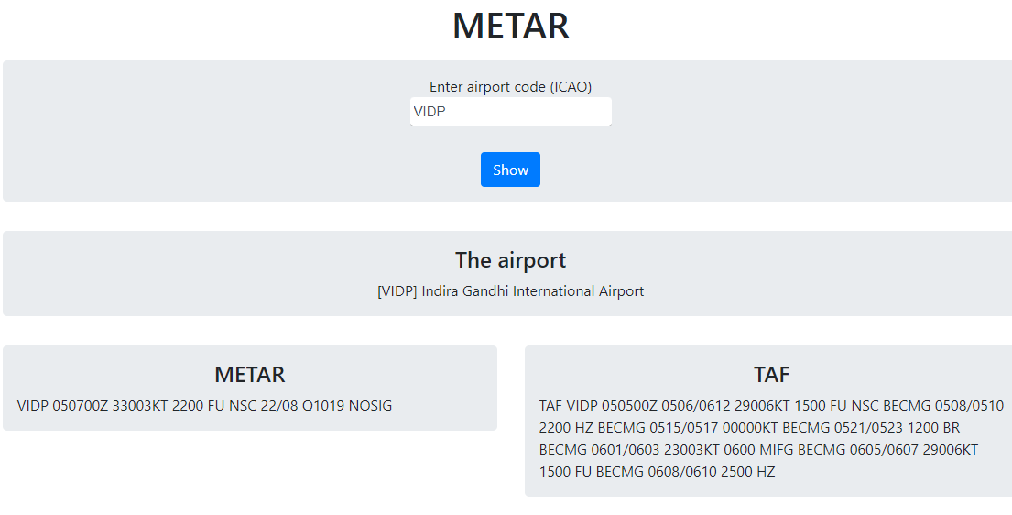

Figure VIDP raw test

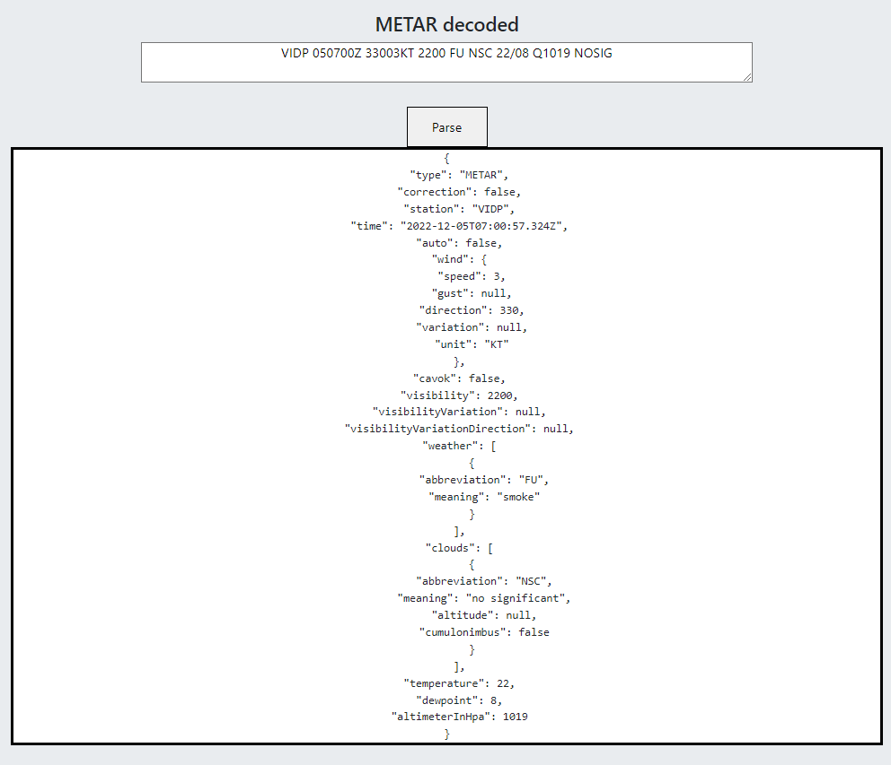

Figure VIDP decoded test

From this decoded data it shows time and station while also reporting that this is not an automated report from Indira Gandhi International Airport. the wind speed is at 3 knots with direction at 330. CAVOK is false due visibility at 2200 meters or 2.2Km while also weather conditions indicate that there is smoke visible close to the airport. clouds are NSC which means not significant with no cumulonimbus clouds. Temperature is at 22 degrees Celsius and dew point at 8 degrees Celsius with pressure at 1019Hpa.

## 5.3 Summary

In this chapter, the software implementation was discussed and also explained how to test the aviation weather system. This chapter explained how the system operates and its interactions with APIs to get large scale weather data. While also showing how the system operates using the various programming languages used. Furthermore, giving an overview of the important code needed to allow the user to use all the pages. In the tests conducted for the report it included gathering data from 5 different airports and getting the decoded METAR data from the decoder function of the METAR page. the tests were conducted using KJFK, VIDP, OOMS, RJTT and EGLL airports. This provided data from a wide array of airports and could test the functions of system using the different weather conditions the airports were facing. It explained in detail how the decoder function worked and provided insight into how the raw METAR data was decoded using the testdecode.js file.

# Chapter 6 Results and analysis

The main aim of the project was to create weather forecasting application that can help pilots in flight path safety and route plotting to increase flight safety and reduce possibility of accidents. The Aviation Weather System has a variety of functions all created to help pilots. While the main aim was to provide weather data other functions were added to help expand on aiding flight safety. features such as fuel calculation for aircrafts using both IFR and VFR rules, an airport map that has a big number of airports with data such as ICAO codes and descriptions, a functioning weather map using Windy API that can show cloud levels, wind and visibility. A live air traffic page that uses OpenSky API to show the huge number of flights.

The focus of the project is on the METAR page from the prior tests METAR and TAF data is provided accurately. While also the system gathers real time weather data from any airport using its ICAO code. The decoder function of the METAR page also works well using any raw data inserted. Of the 5 airports covered in the tests, RJTT Tokyo Haneda international airport provided the most raw data. Due to this it allowed for the decoder function to fully act on its capabilities. It accurately matches the raw data abbreviations and matches them in the JavaScript file and transmits it as JSON.

Comprehensive study was undertaken to understand how to decode METAR data while also into instrument flight rules and visual flight rules. this required to understand how to properly display weather data that is paramount in aiding flight safety. it can be concluded from the tests conducted and the overall working of the system that this aim was achieved but can still be improved. For example, the project can be improved by showing both raw and decoded METAR data without the need to copy and paste into another input.

Since the main aim of the project was creating a tool to aid in aviation safety other features were added to help in that aim. For example, the fuel calculation page can calculate how much fuel that a certain aircraft will consume depending on distance, cruising speed and other variables. This was done following both IFR and VFR rules for aviation. While a weather map was created to help in creating an easier way for the user to gather specific data points. But this page is missing some data inputs required such as the weight of the aircraft. This is extremely important in calculating fuel consumption over a trip, this will be included in the future works of the project.

From the test of KJFK airport METAR report and the comparison from METARreader.com, it can be seen that the system is accurate and provides data that is recognized and used internationally. While even the decoded data does match the other application, this shows the accuracy of the decode function.

Many more tests were ran using different airport they all returned a METAR report as long it as the airport is registered with the ICAO. The results vary due the data provided by that airport. For example, OOMS’s raw METAR report returned less data while EGLL provided more. This is due to the weather conditions around the airport, the lesser variables in weather condition less data is returned. This not due to the application but to the data that the airport publishes. The figure below shows how many times the CheckWX API was tested.

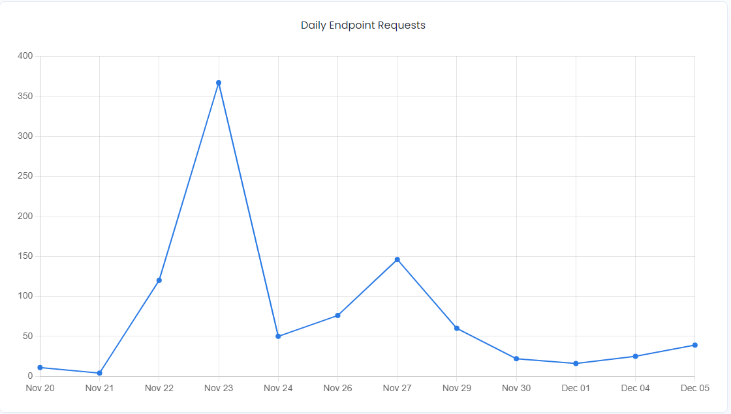

Figure CheckWX API calls

After testing it can be seen that the Aviation Weather System provides accurate meteorological data from airport across world. With varying functions to aid in flight safety and providing pilots with tools to help in flight planning.

## Summary

This chapter discusses the results covered in the testing phase that was carried out. The system was rigorously tested in varying weather conditions covering the 5 tested airports. It all presented accurate data and shows the that the aim and objectives of the project was achieved. The chapter also discussed some additional features of the project and how it is utilized to provide more wide-ranging tools to help in aviation safety.

# Chapter 7 Conclusion

In conclusion, this provides an overview of the Aviation Weather System for flight path safety. From the introduction the aim and motivation to start the proposed project is explained. While also giving some objectives that the project aims to meet and key challenges that the project faces. A literature review was provided for 5 different journal articles and conference papers regarding weather forecasting web applications and similar API interactions. All articles chosen were based on authors that have completed projects with a similar aim and scope. After reviewing these articles many information was gathered in terms of what APIs to use and best Databases for the creation of Aviation Weather System for flight path safety and route plotting. a pre design chapter was introduced and explains using UML diagrams and Database Entity relationship diagram to explain some of the design methods that would be chosen. it provides a general direction of which design methodologies were chosen to complete the aim.

The implementation chapter showcases the steps taken to implement the weather forecast application for aviation. While also delving into the interaction between the APIs such as CheckWX API with the building principles behind it. Providing examples from the source code to show how an external database was connected to application. Web pages such as METAR, airport map and others. While also delving into the underlying JavaScript files to explain the principles that allowed real time weather data from any airport in the world. Significant study into Aviation law to create the METAR decoder and fuel calculation. The application required an understanding of IFR and VFR to aid the objectives of the project.

In the system testing chapter, 5 different airports METAR data were called to showcase the accuracy of the weather forecasts. While also comparing the data using another application completing another objective. From this chapter it showed that both the call to the API was working well and the decoder section was functional with accurate decryption of the raw METAR data. One of the aspects that could be improved would be using decimals to pinpoint temperature and dewpoint more accurately, but this has almost no affect in real world application. While another might be to automatically decode the data gathered from CheckWX API to facilitate easier use.

While also the results discussed showcased the strong aspects of the project while also giving insight on what could have been better. The fuel calculation page could use more in-depth variables to accurately calculate fuel consumption. At its current state it should only be used for aircrafts with no extra weight or luggage. In the same page a runway check was included to aid smaller airports in calculating which runway should be used but this also needs more improvements. Even though it still showcased that all of the project objectives and aim were completed successfully.

From the prior chapters it can be observed that the Aviation Weather system achieved the discussed objectives. It gathers weather data from airports all across the planet while using an internationally used aviation METAR and displays it immediately. The system only cost 0.400 Omani rials to create as most of the APIs used had free calls daily up to a certain limit. The Aviation Weather System can be used by any pilots to get weather data from any airport and is proven to provide accurate data. with many different functions available such as an live weather map, airport map, a live air traffic page and fuel calculation page.

# Chapter 8 future work

The Aviation Weather System is easily scalable this is due to the nature of the APIs used. If the application reaches it limit in daily calls it can easily increase by paying in accordance to the growth of it. From the tests ran it can be seen that although both METAR and the decoder works fine it could be improved ease of use. This could be accomplished by automatically decoding the raw METAR data without the user needing to copy and paste the data. if this is achieved it can maximize the efficacy in which the user interacts with the project. while in the airport map page more airports could be added. This can be done by creating a google tags account instead of using GitHub.

Furthermore, the database could be expanded to include a login page with accounts tracking gathered METAR data showing time of access and presenting it back to the user. This could provide better inclination of weather status to pilots over the course of calls to CheckWX API.

Some of the issues that might appear in the future is that the application might be too dependent on a CheckWX API to gather METAR data. it would be recommended to maybe include another API option to fetch METAR data from. If the API went down it would leave the application stranded with no recourse. Thankfully, due to the way the application created another API could be swapped in with only a simple change in URL and API key in scriptM.js file. While also adding METAR gathering using the airport name in the search bar as well would be recommended for future improvement.

All of these improvements can be made to aid in decreasing potential weather hazards when flying for pilots. Although they not are inhibiting the application from achieving its aim and objectives it would be wise to consider as they add increased functionality to the Aviation Weather System.

# References

Beeharry, Y., Fowdur, T.P. and Sunglee, J.A. (2019). *A Cloud-Based Real-Time Weather Forecasting Application*. [online] IEEE Xplore. doi:10.1109/℡SIKS46999.2019.9002327.

Box, D., Ehnebuske, D. and Kakivaya, G. (2000). Simple object access protocol (SOAP) 1.1. [online] Available at: https://www.researchgate.net/profile/Satish-Thatte/publication/239553871_Simple_object_access_protocol_SOAP_11/links/54489e4e0cf2f14fb8142a59/Simple-object-access-protocol-SOAP-11.pdf.

Bucanek, J. (2009). *Learn Objective-C for Java Developers*. [online] *Google Books*, Apress, pp.353–354. Available at: https://books.google.com.om/books?id=zaSzZKYoBAAC&printsec=frontcover&dq=model+view+controller&hl=en&sa=X&ved=2ahUKEwjfxefvxf32AhVYNuwKHci3CrAQuwV6BAgDEAc#v=onepage&q=model%20view%20controller&f=false [Accessed 5 Apr. 2022].

Cerami, E. (2002). *Web Services Essentials: Distributed Applications with XML-RPC, SOAP, UDDI & WSDL*. [online] *Google Books*. ‘O’Reilly Media, Inc.’ Available at: https://books.google.com.om/books?hl=en&lr=&id=tIM4DwAAQBAJ&oi=fnd&pg=PR5&dq=WSDL&ots=41DEnf5C59&sig=t91115-d7QfZSPKrWi1-BIZuwHA&redir_esc=y#v=onepage&q=WSDL&f=false [Accessed 24 May 2022].

Chen, Y. (2020). COVID‐19 Pandemic Imperils Weather Forecast. *Geophysical Research Letters*, 47(15). doi:10.1029/2020gl088613.

Fowdur, T.P., Beeharry, Y., Hurbungs, V., Bassoo, V., Ramnarain-Seetohul, V. and Lun, E.C.M. (2018). Performance analysis and implementation of an adaptive real-time weather forecasting system. *Internet of Things*, 3-4, pp.12–33. doi:10.1016/j.iot.2018.09.002.

Ginardi, R.V.H., Munif, A., Nurul, K.W., Rosyidi, A., Khoiruddin, A. and Perdana, R. (2017). *System design to use weather forecast amp; current condition information on travel route with KNN and graphical data on Android application*. [online] IEEE Xplore. doi:10.1109/ICTS.2017.8265685.

Google.com. (2022). *Avertissement de redirection*. [online] Available at: https://www.google.com/url?sa=i&url=https%3A%2F%2Fwww.scnsoft.com%2Fblog%2Fnosql-databases&psig=AOvVaw3ThRLla6Fuv4n3JZwo2wzc&ust=1653424024094000&source=images&cd=vfe&ved=0CAwQjRxqFwoTCND85s-69vcCFQAAAAAdAAAAABAP [Accessed 23 May 2022].

Green, B. and Seshadri, S. (2013). *AngularJS*. [online] *Google Books*. ‘O’Reilly Media, Inc.’ Available at: https://books.google.com.om/books?hl=en&lr=&id=eNExy_X1YYcC&oi=fnd&pg=PR2&dq=angularjs+framework&ots=wB3hD1HdT8&sig=f5irJQd9DqN0f2NrLxu3ssdxs0c&redir_esc=y#v=onepage&q=angularjs%20framework&f=false [Accessed 5 Apr. 2022].

Gultepe, I., Sharman, R., Williams, P.D., Zhou, B., Ellrod, G., Minnis, P., Trier, S., Griffin, S., Yum, Seong.S., Gharabaghi, B., Feltz, W., Temimi, M., Pu, Z., Storer, L.N., Kneringer, P., Weston, M.J., Chuang, H., Thobois, L., Dimri, A.P. and Dietz, S.J. (2019). A Review of High Impact Weather for Aviation Meteorology. *Pure and Applied Geophysics*, 176(5), pp.1869–1921. doi:10.1007/s00024-019-02168-6.

Hernandez, R. (2021). *The Model View Controller Pattern – MVC Architecture and Frameworks Explained*. [online] freeCodeCamp.org. Available at: https://www.freecodecamp.org/news/the-model-view-controller-pattern-mvc-architecture-and-frameworks-explained/.

Hussain, M.M., Avci, B., Trajcevski, G. and Scheuermann, P. (2016). *Incorporating Weather Updates for Public Transportation Users of Recommendation Systems*. [online] IEEE Xplore. doi:10.1109/MDM.2016.57.

Jadhav, M. (2015). *Single Page Application using AngularJS*. [online] citeseerx.ist.psu.edu. Available at: https://citeseerx.ist.psu.edu/viewdoc/download?doi=10.1.1.736.4771&rep=rep1&type=pdf.

Kolokolov, Y., Monovskaya, A., Volkov, V. and Frolov, A. (2017a). *Intelligent integration of open-access weather-climate data on local urban areas*. [online] IEEE Xplore. doi:10.1109/IDAACS.2017.8095124.

Kolokolov, Y., Monovskaya, A., Volkov, V. and Frolov, A. (2017b). *Intelligent integration of open-access weather-climate data on local urban areas*. [online] IEEE Xplore. doi:10.1109/IDAACS.2017.8095124.

McCown, F. and Nelson, M.L. (2009). What happens when facebook is gone? *Proceedings of the 2009 joint international conference on Digital libraries - JCDL ’09*. doi:10.1145/1555400.1555440.

Munandar, A., Fakhrurroja, H., Rizqyawan, M.I., Pratama, R.P., Wibowo, J.W. and Anto, I.A.F. (2017). Design of real-time weather monitoring system based on mobile application using automatic weather station. *2017 2nd International Conference on Automation, Cognitive Science, Optics, Micro Electro-­Mechanical System, and Information Technology (ICACOMIT)*. doi:10.1109/icacomit.2017.8253384.

Osorio, E.E.C., Kang, S., Kim, B.-S., Lim, J., Kim, K.H. and Kim, K.-I. (2017). *Development of data collecting system for forecasting with meteorological sensors*. [online] IEEE Xplore. doi:10.1109/ICOIN.2017.7899534.

Pop, D.-P. and Altar, A. (2014). Designing an MVC Model for Rapid Web Application Development. *Procedia Engineering*, 69, pp.1172–1179. doi:10.1016/j.proeng.2014.03.106.

Ripalda, D., Guevara, C. and Garrido, A. (2020). Framework Based on Gestalt Principles to Design Mobile Interfaces for a Better User Experience. *Advances in Intelligent Systems and Computing*, pp.158–165. doi:10.1007/978-3-030-51828-8_21.

Sahl, R., Dupont, P., Messager, C., Honnorat, M. and Vu La, T. (2018). *High-Resolution Ocean Winds: Hybrid-Cloud Infrastructure for Satellite Imagery Processing*. [online] IEEE Xplore. doi:10.1109/CLOUD.2018.00127.

Srinivasan, K., Nema, A., Huang, C.-H. and Ho, T.Y. (2018). *Weather Forecasting Application Using Web-Based Model-View-Whatever Framework*. [online] IEEE Xplore. doi:10.1109/ICCE-China.2018.8448971.

Strauch, C. and Kriha, W. (n.d.). *NoSQL Databases Lecture Selected Topics on Software-Technology Ultra-Large Scale Sites*. [online] Available at: https://bigb.es/lectures/2014/15.5.pdf.

W3schools.com. (2012). *AngularJS Tutorial*. [online] Available at: https://www.w3schools.com/angular/.

Wahdiniwaty, R., Setiawan, E.B., Auliardi, F. and Wahab, D.A. (2019). Application Model for Travel Recommendations Based on Android. *IJNMT (International Journal of New Media Technology)*, 6(1), pp.9–16. doi:10.31937/ijnmt.v6i1.1059.

Williamson, K. (2015). *Learning AngularJS: A Guide to AngularJS Development*. [online] *Google Books*. ‘O’Reilly Media, Inc.’ Available at: https://books.google.com.om/books?hl=en&lr=&id=8bd1BwAAQBAJ&oi=fnd&pg=PR5&dq=angularjs+security+issues&ots=W0FievW8U7&sig=iS8BXUpZGZzMAhsiFVNgMLID7yo&redir_esc=y#v=onepage&q&f=false [Accessed 5 Apr. 2022].

Wolfe, H.P., M.A, M.H.P.W. and NewMyer, D.A. (1985). *Aviation Industry Regulation*. [online] *Google Books*. SIU Press. Available at: https://books.google.com.om/books?hl=en&lr=&id=71o8dq83Hs8C&oi=fnd&pg=PP10&dq=aviation+regulations&ots=D5WFEGk73C&sig=Qk1MRzscnTugeFGpon6sw6NSrlo&redir_esc=y#v=onepage&q=aviation%20regulations&f=false [Accessed 21 May 2022].

www.caa.gov.om. (n.d.). *Civil Aviation Authority - Regulations*. [online] Available at: https://www.caa.gov.om/regulations.

Zhao, S. and Fan, L. (2010). *Reports the current weather conditions on cell phones using web services*. [online] IEEE Xplore. doi:10.1109/COGINF.2010.5599778.

# Approved Project proposal









